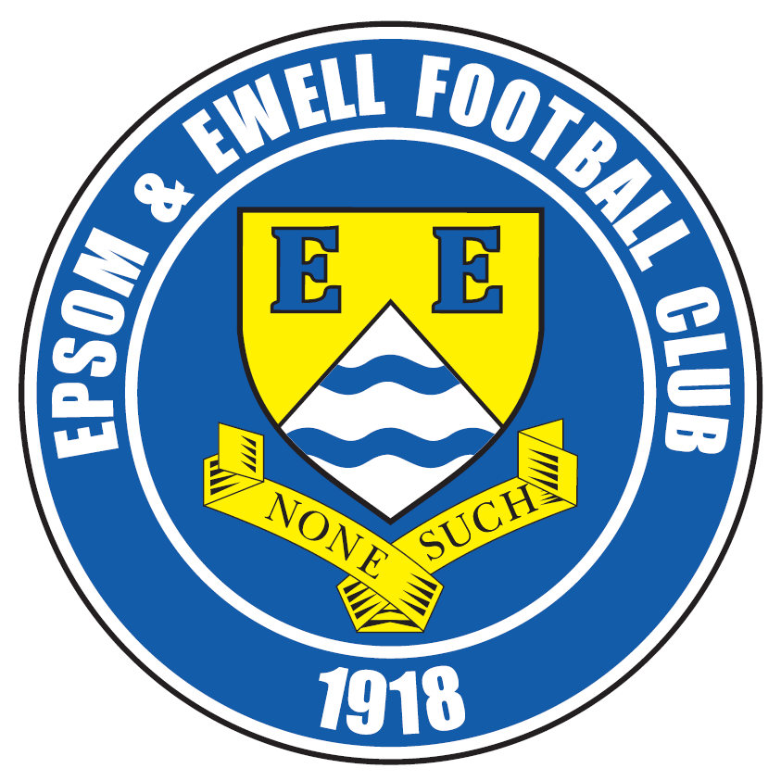 | Epsom & Ewell F.C.  25  v  Knaphill F.C.  Saturday, 18th April 2015
Good afternoon! For our final home league match of the season we welcome the players and officials of Knaphill F.C. along with the match officials and of course our own regular supporters.

Our opponents have been here already this season when we edged past them 2-1 in a League Cup tie in October. A month before that we won 4-1 at Redding Way in Glyn’s first match as Manager. At present they face an uncertain future as the relegation battle has been a really competitive one this season with many teams getting dragged in and even at this late stage it is too close to call.

For our part we have had a number of matches since our last appearance at High Road; a 2-1 victory over Colliers Wood United. We slipped up 1-0 at Horley Town on Easter Monday morning to break our six match winning streak and it must be said that it wasn’t our finest hour, although if we had come away from the New Defence with a goalless draw they couldn’t have complained. We then went to Molesey on Wednesday evening where we were dominated 5-0 by the best team we have faced this season. However, we managed to pick ourselves up and won 3-0 at Windsor on the following Saturday with two from Daryl Cooper-Smith and the other in between from Matt Farrell. All three came from set pieces.

It is fair to say that it has been an eventful season! We have had a new Chairman, a new Manager and many new faces within the playing staff. From an early stage I felt that we would be good enough to survive at this level, despite the substantial cut to our playing budget this season and so it has proved. With a full pre-season to help them get some new players in I am sure that Glyn and Matt will put a team together that will be again competing for the top positions next term.

We give our thanks to Chipstead F.C. for accommodating us and confirm that we will be here next season. In the meantime our own plans for a new site are more advanced than they have been for over a decade. Many obstacles remain in our way but all parties at the club are now pulling in the same direction and we should have some progress to report on by the start of the new season.

Next Saturday from 7pm we are at the Epsom Common Working Men’s Club for our end of season Presentation evening. If you are interested, tickets cost just £10 and include your choice of meal from a selection available. Just ask any Committee member for details. The drinks are cheap and it is at a local venue so it would be really nice if we could see many of you there.

Also, there are Player of the Year slips around, although the deadline is today so please pass them back to a Committee Member before you leave this afternoon or your vote won’t count.

Finally, I would like to thank our Kit Sponsors Intercem for their generous donation of the blue kit this season. We are grateful for any donations or sponsorship and if you can help, just let us know.

Glyn, the players and the club are grateful for your support during the season. See you next year?

Rich

Cover photo this week by Gemma Jarman

Kyle Hough scores our winner against
Colliers Wood United on Saturday 4th April


Cherry Red Records
Combined Counties League
Premier Division Table 2014/15
inc Wednesday  15th April 2015 | P | W | D | L | F | A | Pts | GD | H | A
Camberley Town | 38 | 26 | 7 | 5 | 86 | 30 | 85 | +56 | 2-4 | 0-1
Molesey | 37 | 27 | 1 | 9 | 101 | 36 | 82 | +65 | 1-3 | 0-5
Ashford Town (Mx) | 39 | 24 | 5 | 10 | 92 | 54 | 77 | +38 | 2-4 | 3-1
Cove | 37 | 23 | 7 | 7 | 86 | 57 | 76 | +29 | 2-2 | 0-1
Windsor | 38 | 21 | 4 | 13 | 89 | 55 | 67 | +34 | 0-5 | 3-0
Spelthorne Sports | 38 | 19 | 5 | 14 | 69 | 60 | 62 | +9 | 4-3 | 3-0
Badshot Lea | 38 | 18 | 5 | 15 | 73 | 55 | 59 | +18 | 3-0 | 2-4
Epsom & Ewell | 38 | 18 | 4 | 16 | 71 | 65 | 58 | +6 | - | -
Hartley Wintney | 38 | 16 | 5 | 17 | 55 | 71 | 53 | -16 | 2-1 | 1-2
Farnham Town | 38 | 14 | 7 | 17 | 72 | 90 | 49 | -18 | 2-4 | 2-0
Colliers Wood United | 38 | 14 | 6 | 18 | 68 | 67 | 48 | +1 | 2-1 | 2-3
Westfield | 38 | 12 | 10 | 16 | 60 | 65 | 46 | -5 | 3-1 | 0-4
Bedfont Sports | 38 | 14 | 4 | 20 | 51 | 72 | 46 | -21 | 0-1 | 2-0
Raynes Park Vale | 37 | 12 | 8 | 17 | 49 | 62 | 44 | -13 | 0-1 | 2-0
Horley Town | 37 | 12 | 8 | 17 | 67 | 84 | 44 | -17 | 2-2 | 0-1
Knaphill | 38 | 12 | 6 | 20 | 55 | 80 | 42 | -25 | 18/4 | 4-1
Mole Valley SCR | 38 | 12 | 6 | 20 | 61 | 92 | 42 | -31 | 1-0 | 5-2
Hanworth Villa | 38 | 11 | 8 | 19 | 55 | 71 | 41 | -16 | 1-1 | 5-2
Chertsey Town | 38 | 12 | 5 | 21 | 65 | 93 | 41 | -28 | 1-2 | 2-1
Guildford City | 37 | 11 | 4 | 22 | 67 | 98 | 37 | -31 | 4-1 | 3-1
Frimley Green | 38 | 9 | 5 | 24 | 59 | 94 | 32 | -35 | 0-0 | 25/4

Lucky Day? – 18th April
Played 20 - Won 8 Drawn 4 Lost 8 - F 42 A 39 - PPG 1.40 - Average
Club record against Knaphill
Played 3 - Won 3 Drawn 0 Lost 0 - F 9 A 4 - PPG 3.00 - Perfect
Last visit
Tuesday 14th October 2014 - Won 2-1 - League Cup - Second Round

Glyn Mandeville
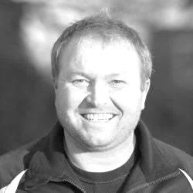
Greetings from the Management team!

I would like to start by saying a big thank you to my staff, a.k.a. Matt Smith, Alex McKay, Steve Eacott and Ken Jones, and also the committee for all the help and support this season and for giving us the chance when Lyndon left, cheers chaps.

Also, thanks to the lads since we took over, they have been great. I have had a lot of fun this season and believe we have played some good football, the lads work hard and I am gutted for them when we don't get the results we deserve.

We hope the lads will stay together with a few additions next season, but with two games still to play I am sure you will agree we have been good value with only a few bad performances i.e. Lingfield, Camberley (2nd half), Molesey, but with loads of plusses for next season. I really look forward to meeting up with them again.

Good luck to the lads for the last two games, and I wish all the supporters a great summer and look forward to seeing you next season. Safe trip home.

Yours in football

Manders

Anthony Panayi
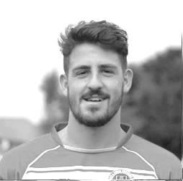
Good afternoon!

Today we welcome players and supporters from Knaphill F.C.

This will be the final home match of a season that has had its fair share of ups and downs.

On a whole we have responded very well since a change of management mid-way through the season and when we have had everyone available we have shown we are a match for any side in the division.

A guaranteed minimum of 9th is nowhere near where the club should be and I'm sure next season the boys will prove that and challenge the top half of the division once again.

I hope that you all enjoy this afternoon’s game and thank you once again for your support through the season!

COYS!

Ant

Pete Beddoe
Another football season is nearly over, this time with new personnel involved. As the custodians of the Club, the new Committee has attempted to secure the future of the Club both on and off the field.


On the playing front Glyn Mandeville (“Manders”) took over seamlessly from the Knaphill away match in September and after a bedding down period has produced a team that plays well, has good team spirit and has had some excellent performances, especially against the better teams. We should finish either 7th or 8th which is a very creditable performance. Manders and his Management team of Matt Smith (“Smudger”), Steve Eacott & Alex McKay should be very proud of that. A special word for Ken Jones our physio who has continued to treat the players when necessary, which has been invaluable.

It is important that the Club’s finances are properly administered. Our treasurer, Steve Dyke, has maintained strict budgetary constraints for both the players’ expenses and for all the administrative expenses of the Club. The better this is carried out, the better placed we are to fund the relocation of the Club back to the Borough. The relocation of the Club as a joint venture with Epsom & Ewell Colts F.C. continues apace. A Sports Consultant is now employed and I think it can be said that the Club is further advanced down the relocation front than at any time since we left West Street.

Although the Committee works as a team with full consultation at all times every one has been empowered to take full responsibility for their own duties.

Richard Lambert is now our Media Officer and has taken over the reins of editing the programme and managing the Club website. He deals very efficiently with all aspects of publicity.

Paul Marshall is one of our unsung heroes dealing with the kit before and after the matches, promoting the sale of our Super Six Predictor forms and filling in on gate duties at the drop of the hat. Last but not least he navigates me to the away grounds and gets me back safely!

Mel Tough despite his injury has carried out his Club membership duties most effectively and Mike Lovett has been our link with the Colts and has contributed very cogently to our relocation project.

Mention has to be made to others such as Dougie Burns, Nigel Pond, George Holland & Ian Twyford, who have helped on match days when circumstances permit. A final word is extended to Gemma Jarman for her excellent photographic work. Many thanks to you all.

None of this would be possible without the help of Chipstead F.C. who provide the ground facilities, including the excellent pitch. In fact no matches were postponed there because of waterlogged pitches which is all due to all the experience of the ground staff.

Thanks to Mick, Geoff, Heather & Terry and everyone else at High Road for making life so

easy for us there. A special word to Alan Cooper (“Coops”) who looks after us on match days. Finally we were grateful to Sophie and Karen and all their team for providing hospitality refreshments and excellent service at the Tea Bar all season.

Thanks are extended to the brilliant support of our faithful band of loyal supporters. All augers well for an even more successful season next year with Manders and his team at the helm.

Finally a personal note, I would like to thank everyone connected with the Club for the tremendous support you have given me throught the season. This support has been most appreciated.

Come on you Salts.

Peter

Sam Currie

Good afternoon and welcome to High Road in what is our final home game and penultimate game of the season.

On reflection I feel this season has been a good one - the emergence of a young squad with the sprinkling of experienced talent has meant that we have reformed well after Glyn took the reins and Smudge became the full time assistant.

Considering we have had many injuries, and should I say it quietly, suspensions through the season - a top 9 (or even better) finish, a cup Quarter Final and some big performances, particularly away from home has meant we have plenty to build on for next year.

There are still two games to go and after picking ourselves off after the poor performance against Molesey, the fantastic result away at Windsor has put us in good stead to conclude the 2014/15 season with two big performances.

We hope you enjoy today's game and may I take this opportunity to thank the gaffa, Smudge, Steve and Ken for their important efforts, all the Committee for their top work, and the supporters for their continued support - which means so much to the lads.

Also to Mrs Jarman (who somehow manages to make some of the lads look respectable during games) with the photography archive she keeps up to date on almost a game by game basis.

And finally, Rich who produces the top programmes and a massively detailed website which would not look out of place for a football League club.

All these factors help to the successful foundations of a strong developing club.

All the best and up the Salts

Sam

Recent Results and Remaining Fixtures
Combined Counties League Cup SF – Wednesday 1st April
Colliers Wood United | 5-2+ | Farnham Town
Combined Counties League – Saturday 4th April
Ashford Town (Mx) | 2-2 | Knaphill
Chertsey Town | 3-3 | Frimley Green
Cove | 2-0 | Windsor
Epsom & Ewell | 2-1 | Colliers Wood United
Farnham Town | 1-1 | Bedfont Sports
Guildford City | 1-4 | Camberley Town
Hartley Wintney | 1-3 | Westfield
Molesey | 0-1 | Hanworth Villa
Raynes Park Vale | 2-3 | Horley Town
Spelthorne Sports | 1-0 | Mole Valley SCR
Combined Counties League – Easter Monday 6th April
Bedfont Sports | 0-2 | Ashford Town (Mx)
Camberley Town | 2-0 | Badshot Lea
Frimley Green | 1-3 | Farnham Town
Hanworth Villa | 0-0 | Spelthorne Sports
Horley Town | 1-0 | Epsom & Ewell
Knaphill | 2-1 | Hartley Wintney
Mole Valley SCR | 2-1 | Molesey
Westfield | 2-2 | Guildford City
Windsor | 5-1 | Chertsey Town
Combined Counties League – Wednesday 8th April
Molesey | 5-0 | Epsom & Ewell
Combined Counties League – Thursday 9th April
Badshot Lea | 0-1 | Hanworth Villa
Raynes Park Vale | 0-1 | Guildford City
Combined Counties League – Saturday 11th April
Bedfont Sports | 1-0 | Badshot Lea
Camberley Town | 1-1 | Ashford Town (Mx)
Colliers Wood United | 6-2 | Windsor
Frimley Green | 1-2 | Raynes Park Vale
Hartley Wintney | 3-0 | Hanworth Villa
Horley Town | 1-0 | Spelthorne Sports
Knaphill | 4-2 | Guildford City
Mole Valley SCR | 2-2 | Cove
Recent Results / Fixtures
Combined Counties League – Saturday 11th April
Westfield | 5-0 | Farnham Town
Windsor | 0-3 | Epsom & Ewell
Combined Counties League – Tuesday 14th April
Badshot Lea | 4-1 | Guildford City
Farnham Town | 1-0 | Ashford Town (Mx)
Raynes Park Vale | 1-1 | Hanworth Villa
Westfield | 1-3 | Bedfont Sports
Combined Counties League – Wednesday 15th April
Colliers Wood United | 1-2 | Molesey
Combined Counties League – Saturday 18th April
Ashford Town (Mx) | V | Hanworth Villa
Badshot Lea | V | Windsor
Chertsey Town | V | Horley Town
Cove | V | Westfield
Epsom & Ewell | V | Knaphill
Guildford City | V | Colliers Wood United
Hartley Wintney | V | Mole Valley SCR
Molesey | V | Camberley Town
Raynes Park Vale | V | Bedfont Sports
Spelthorne Sports | V | Frimley Green
Combined Counties League – Tuesday 21st April
Farnham Town | V | Colliers Wood United
Horley Town | V | Badshot Lea
Raynes Park Vale | V | Molesey
Combined Counties League – Wednesday 22nd April
Guildford City | V | Cove
Combined Counties League – Saturday 25th April
Bedfont Sports | V | Chertsey Town
Camberley Town | V | Spelthorne Sports
Frimley Green | V | Epsom & Ewell
Hanworth Villa | V | Cove
Horley Town | V | Farnham Town
Knaphill | V | Raynes Park Vale
Mole Valley SCR | V | Guildford City
Westfield | V | Molesey
Windsor | V | Hartley Wintney

From behind the goal
Epsom & Ewell 2-1 Colliers Wood United
Combined Counties League - Premier Division - Saturday 4th April 2015

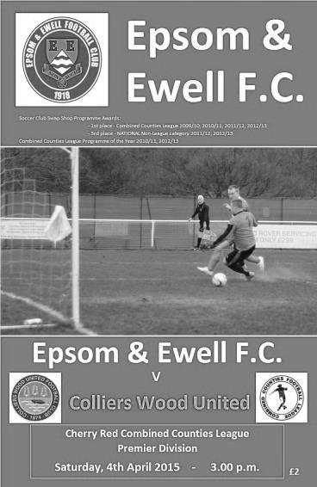
Six in a row as Salts defeat Cup Finalists

League Cup Finalists Colliers Wood United became the latest team to fall victim to the in-form Salts, despite what appears a constant struggle to fill our bench these days.

Even our Manager Glyn Mandeville was away so Matt Smith took charge and also named himself as one of just three substitutes. Under the circumstances it was just as well that Matt Farrell and Dan Dean were back after suspension, whilst James Taylor returned from his one game absence but found Captain Sam Currie in his path so started on the bench alongside new signing James Kavanagh, who had recently joined us from Molesey. In the debit column Alex McKay and Alex McGregor were both away.

Dean was involved early with a solid challenge that you might have got away with back in the seventies, but not nowadays, and from the free kick on the edge of the area the ball hopped up at Michael Eacott but our keeper, playing against his former club was able to react well to hold the ball. Our first threat also came from a free kick after a quarter of an hour but Matt Ferdinando and Sam Robinson got in each other's way a bit and neither made contact with the delivery.

After half an hour of honest combat in which neither team had actually created a noteworthy chance, we earned a penalty. In truth we had been beginning to get on top and as Matt Robinson chased a ball just inside the area, a challenge from the left took the ball and player. It was clear to me that it was a good challenge but the Assistant, from a different angle felt that it was a foul and so Kyle Hough put the ball past Lee Pearce from the spot to give us a 33rd minute lead. This was his ninth penalty of the season, equalling his own club record set twice previously!

By half time it was a deserved lead. Looking back, Eacott had very little to deal with, while our midfield were well on top with 'Agi' Panayiotou alongside Farrell, breaking things up and carrying the ball forward to add to our attacking threat. In

fact it was looking very much like our previous week's win at Guildford and I thought we would go on to extend our lead. I was wrong as with 49 minutes on the clock a ball across the edge of the area was drilled into the far corner by Dan Harding for the equaliser.

The game was fairly even for a while from this point and our passing was not quite as good as it had been. However, in the 63rd minute we restored our lead. Ferdinando had been injured just before the break leading to the introduction of James Taylor. This meant that Sam Currie was now playing further forward on the right and his ball through to Hough was a good one. There was still much to do though and as he ran into the right hand channel between centre half and full back the ball dropped over his right shoulder, yet he adjusted brilliantly to smash the ball in past Pearce with his left foot for his thirty-second goal of the season; a record for him with us and his sixteenth goal in his last ten matches. (see front cover)

We had a scare moments later, when Eacott, hampered by a tight hamstring, dropped the ball. Fortunately we had defenders nearby and were able to clear it away from about a yard out. After 73 minutes another shot from outside the box fizzed just over our crossbar but we had more of our own chances to extend our lead. Currie pulled the ball back to Hough but his shot was not quite low enough and Pearce, who has made countless saves against us while in the colours of Wembley, Bedfont Green and Egham previously, made another good one at full stretch to deny him a second home hat trick in three matches.

Robinson fired a powerful volley just wide but we were caught on the counter attack on the 80 minute mark and Taylor made sure that his man didn't get into the box by crudely upending him outside the area, picking up the inevitable yellow card but in response an Epsom corner was then met superbly by a diving Currie but he couldn't keep his header down and was just off target.

Panayiotou struck at goal in injury time but his shot was parried away and the game finished shortly afterwards with our boys celebrating their sixth straight win; extending our unbeaten run to nine matches in the process. The defenders looked solid, despite the absence of Alex McKay, while in midfield we are looking really good and up front we have the hottest striker in the League. What's not to like?

Team: Michael Eacott, Sam Currie ©, Steve Rowe, Anthony Panayi, Dan Dean, Matt Farrell, Matt Ferdinando, Savva 'Agi' Panayiotou, Kyle Hough, Sam Robinson, Matt Robinson

Subs: James Taylor for Ferdinando (45), James Kavanagh for M.Robinson (86)

From behind the goal
Horley Town 1-0 Epsom & Ewell
Combined Counties League - Premier Division - Monday 6th April 2015

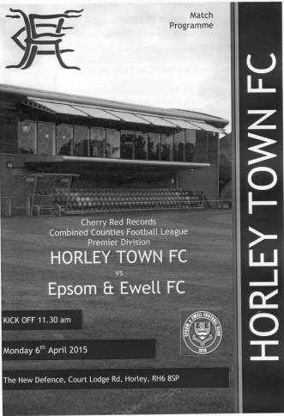
No defence at the New Defence

Who'd have thought it? Of all the places to lose, surely it couldn't be at the New Defence; a venue where we had won on seven previous occasions and against a team in Horley that we have an excellent record against?

Stranger things have happened over an Easter weekend according to the Bible, but it came to pass that on the Monday morning we produced one of our worst performances for a while, got frustrated and lost discipline and our winning record into the bargain. Horley were no angels themselves but deserved the win as they were able to snuff out the threat provided by Kyle Hough, whilst at the other end their young striker Ashley Nadesan got free just the once and took full advantage of the opportunity.

Effectively this was the only difference between two fully committed sides; our boys looking for our seventh straight win, while the home side needed the points in their battle against relegation. Unfortunately, faced with yet another shortage of players due to the injured Matt Robinson and the suspended Matt Ferdinando and Daryl Cooper-Smith we had new boy James Kavanagh and the repaired but untested George Murphy, following his hernia operation as substitutes.

In general this was a scrappy game spoilt by two teams that spent more time trying to settle their own differences after realising that the referee wasn't going to protect them, choosing instead to make a series of mystifying decisions throughout the ninety seven minutes of the game. After 25 minutes of chanceless action you realised it might be one of those days when Hough chased a through ball, only to have the central defender smash the ball off his hands and out for a goal kick. Only he didn't award a goal kick, but awarded a free kick for handball. Later in the game he ignored an identical incident on the touchline. Consistency, what consistency!

A Horley free kick after 28 minutes was fed in and a snap shot at goal followed, but it was hit straight at Michael Eacott who made the save, while at the other end a Sam Robinson free kick almost dribbled through to the home keeper, lacking its usual power. Alex McKay had to get a foot in to make a last ditch challenge at one point but this was all the action in first half until the 44th minute when Horley's Liam Giles and Sam Robinson got tangled up and as Robinson got up another player ran in, leading to our man putting his arm up. It could have been construed as aggressive but looked to me like a protective measure. Either way the two protagonists received a yellow card

while the man running in received nothing for his trouble.

Within a minute and on the other wing, Robinson chased Adam Pullin down and fouled him as he was seeing the ball out for a goal kick. As the Horley defender got up he pushed Robinson to the ground incurring another card, although I feel that Robinson would have got a yellow too, had he not already just had one. Of course this got the crowd involved and on a warm day, the temperature of the game itself started to rise just as the whistle for half time blew.

The second half started with a good run on the left by Savva 'Agi' Panayiotou but he was crowded out and more or less from the clearance the ball was fed into Nadesan who got the wrong side of Steve Rowe who had no cover and drilled the ball under Eacott for a goal against his former team. It came after 49 minutes and was a concern because there had been so few opportunities in the match that you wondered whether that would change. As it turned out most of what happened in the second half was not connected with the football, although the home side nearly doubled their lead with a far post header from a deep free kick that went back across our goal and beyond the opposite post after 62 minutes. Shortly afterwards a low shot on the turn required a smart low save from Eacott.

Then the game took another nasty turn. After 68 minutes David Heaton took a kick at Robinson, leaving him on the ground and the referee issued the red card almost before our man had hit the deck This was followed by our best chance which actually came off the head of a defender from a free kick, but the keeper George Hyde was able to parry the ball for a corner. From the corner a Horley defender collided with Hyde who then dropped the ball. Hough went in after the loose ball and the referee blew the whistle. For a moment it looked as though our striker was about to get a red card for some reason, but fortunately was persuaded to check with his Assistant before doing so, although he still felt the need to give him a yellow card which was equally perplexing as our man had done nothing wrong whatsoever.

It looked to me that the referee was just waiting for the opportunity to even things up and after 79 minutes the unlucky man was James Taylor who appeared guilty only of trying to take a throw on quickly, but was impeded by Nadesan in the process. Maybe Taylor stuck a foot out, but from where I was, when the red card was raised I genuinely thought that it was the home team that were down to nine men as Taylor appeared to be just trying to take a throw on. The referee then showed Nadesan a yellow card.

With both teams down to ten men we had a couple of chances. Rowe's pile driver from fully 35 yards was the perfect height but about a metre wide, while Hough got a shot in but the ball took two deflections and lacked any sort of threat by the time it reached the keeper who gathered it. Seven minutes of injury time followed but nothing of quality was contained in it and by the end many people will have wondered why they bothered to rise from their beds to watch this one!

Team: Michael Eacott, James Taylor, Steve Rowe, Anthony Panayi, Alex McKay, Dan Dean, Sam Currie ©, Matt Farrell, Kyle Hough, Sam Robinson, Savva 'Agi' Panayiotou

Subs: none

Reporting from an unusual position!
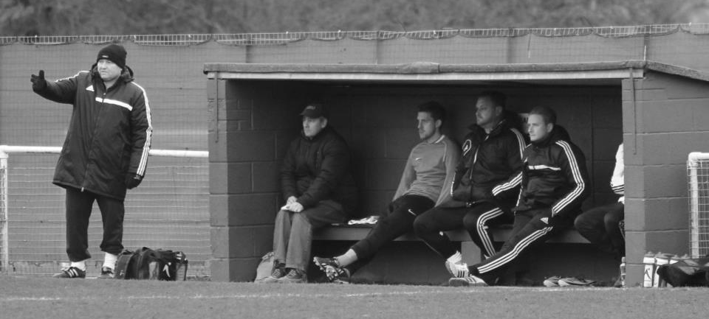
Here is a picture of the home dugout from the Badshot Lea match on Saturday 21st March. All looks fairly straightforward until, hang on, what’s he doing sitting in there on the left?

It occurred to me earlier in the season that despite supporting our club for nearly 34 years I had never experienced life on the other side; in other words, what goes on with the players and Management within the inner sanctum of the dressing room.

I put the idea of a day “behind the lines” to Glyn and on the day of the Badshot Lea game he invited me in for an insight into what actually goes on where the supporters cannot see.

I quietly sat in the corner as the players completed their pre-match preparations before going out to warm up. Although I won’t go into detail, it was interesting to see some people sitting deep in thought, others chatting to each other or happy to listen to the loud music on the radio, while a couple were even reading the programme! A couple of players had various limbs strapped up and away they went for the warm up.

The training was conducted mostly by Assistant Manager Matt Smith with Glyn watching on, content to deal with other matters that needed attention from mundane matters such as ensuring that the match balls were pumped up, to more necessary ones like ensuring that Pete Beddoe had the details of the team for the club paperwork. Meanwhile Matt put them through their paces. Glyn has his training badges too but clearly has complete faith in Matt which enables him to think about any other issues. There is so much more to being a Manager than just the football these days.

On the board were clear instructions for certain positions that players had to take in the event of any set pieces, whether attacking or defending, and there was a reminder to all players that discipline had to be “on point”.

The players came in from their warm up and Glyn and Matt went through some final instructions with the players and we all went out to take the field. I was carrying the valuables bag and the physio bag so I felt a bit less of an interloper and more a part of the team! I took my place in the dugout and settled down to watch the match.

Maybe it was because there were only two substitutes, but it was a lot quieter in there than I was expecting. Sam Currie was being rested before the Westfield game while Ali Dewar was back and available but neither said much and there was a general aura of serenity. Matt and Glyn are of a similar demeanour to Lyndon in that there is not an enormous amount of shouting going on and not a lot of interaction was required between them during the half, although there was concern about our slow start to the game, requiring Michael Eacott to make a great save early on to keep the scores level.

We took the lead from a penalty awarded for a foul on Matt Ferdinando. Apart from Smudger who was absolutely certain that it was a penalty, the others in the dugout, including myself probably didn’t feel that the foul would be given as it was one of those borderline decisions that you normally only get in the middle of the park. There was calm in the dugout as Kyle stepped up, clearly expecting, as we do, that he would score.

In fact there was not much celebration when Kyle scored our second goal either, although this was largely because it was difficult to see at first whether the ball had gone in or whether it had been deflected into the side netting and the whistle blew for half time quickly afterwards. At the break both Matt and Glyn said a few words; Matt dealing more with the tactical aspects while Glyn concentrated on the motivational side of things. It was silent and disciplined in the dressing room as the instructions were given out, and although there was time at the end for a small discussion, everyone realised that this was listening time as we would be back out there very shortly.

The second half came and went very quickly and when Kyle got his third goal to complete his first ever home hat trick, there were proper celebrations on the bench. In fact I got to thinking how surprising it was that no one had banged their heads on the low roof when getting up. I put it down to the fact that they had probably all done it before and learned the right way to get up from the dugout, something I too had found out the hard way by the end of the match!

Then it was all over and we had won 3-0. The opposition had been quite disappointing but at the same time we had played well, taken our chances and by the end could have won by more. In the dressing room there was a realisation by the players of a job well done but the talk turned quickly to the upcoming bowling evening that they had planned for that evening with very little discussion about the match they had just won, certainly far less than would have been going on amongst the supporters outside.

There was just time for me to witness the Glyn victory dance (you had to be there!) before I left the players to get changed and do my own match duties. It was a fascinating experience to actually get to watch our team in a different manner after all these years, although the dugout provides one of the worst views of a game I have experienced and if I were a Manager I think I would be one of those who sat high up in the stand for a better view of the action! Even so, I hope to get the chance to do it again at some point, seeing as I have a claim now for the position of lucky team mascot!

Thanks again to Glyn and Matt for giving me the opportunity. It was my favourite day of the season!

Above and Below
Ryman League Division One South Table
including Tuesday 14th April | P | W | D | L | F | A | Pts | GD
Burgess Hill Town | 44 | 32 | 9 | 3 | 99 | 38 | 105 | +61
Faversham Town | 44 | 29 | 7 | 8 | 105 | 49 | 94 | +56
Folkestone Invicta | 44 | 28 | 10 | 6 | 102 | 46 | 94 | +56
Merstham | 44 | 25 | 12 | 7 | 101 | 50 | 87 | +51
Whyteleafe | 44 | 23 | 12 | 9 | 91 | 58 | 81 | +33
Worthing | 44 | 21 | 10 | 13 | 88 | 60 | 73 | +28
Three Bridges | 44 | 20 | 9 | 15 | 91 | 91 | 69 | 0
Whitstable Town | 44 | 19 | 11 | 14 | 80 | 71 | 68 | +9
Herne Bay | 44 | 19 | 8 | 17 | 60 | 64 | 65 | -4
Guernsey | 44 | 18 | 6 | 20 | 86 | 91 | 60 | -5
Sittingbourne | 44 | 15 | 11 | 18 | 52 | 66 | 56 | -14
Corinthian-Casuals | 44 | 16 | 8 | 20 | 61 | 79 | 56 | -18
South Park | 44 | 16 | 7 | 21 | 74 | 101 | 55 | -27
Hythe Town | 44 | 14 | 11 | 19 | 78 | 73 | 53 | +5
Tooting & Mitcham United | 44 | 13 | 14 | 17 | 70 | 66 | 53 | +4
Walton Casuals | 44 | 16 | 5 | 23 | 61 | 85 | 53 | -24
Walton & Hersham | 44 | 13 | 10 | 21 | 54 | 72 | 49 | -18
Carshalton Athletic | 44 | 13 | 9 | 22 | 59 | 73 | 48 | -14
Chipstead | 44 | 13 | 9 | 22 | 60 | 81 | 48 | -21
East Grinstead Town | 44 | 13 | 6 | 25 | 54 | 90 | 45 | -36
Hastings United | 44 | 11 | 11 | 22 | 53 | 67 | 44 | -14
Ramsgate | 44 | 12 | 8 | 24 | 54 | 81 | 44 | -27
Redhill | 44 | 9 | 11 | 24 | 65 | 96 | 38 | -31
Horsham | 44 | 10 | 6 | 28 | 47 | 97 | 36 | -50
Although Burgess Hill Town have lost three matches in recent weeks since Whyteleafe were the first to claim their scalp, they are now Champions of the League and will take their place in the Ryman Premier League next season. In fact, at the top the four playoff teams are also confirmed and the only matter of interest is for who will be third and host Whyteleafe and who will be fourth and host Merstham

At the bottom it is a little more interesting although mighty Horsham have been confirmed in the relegation positions and barring a 17 goal swing in the final two matches, have been joined by Redhill. One club has to be relegated in accordance with F.A. guidelines and it could be either.

In terms of relegations, there should be 14 normally, being replaced by the same number from Step Five. However, two Step Five leagues are not promoting and seven clubs are currently in line for reprieves, so Ramsgate will survive even with a bottom three position, unless they are overhauled by Redhill who host Chipstead today and travel to South Park next Saturday. Horsham host Ramsgate today and then finish at Tooting & Mitcham United.

But where will they be relegated to? Current “independent” projections place Horsham in the Sussex League and Redhill in with us. Should that happen there is no way Horley will move to the Sussex League and likewise for the nightmare scenario of our club being placed in the Southern Counties East (formerly Kent) League. It might seem unlikely but it was a real possibility and regrettably remains so in future seasons until we can return to our home Borough.

Above and Below
Combined Counties League Division One Table
including Tuesday 14th April | P | W | D | L | F | A | Pts | GD
Farleigh Rovers | 28 | 20 | 4 | 4 | 61 | 34 | 64 | +27
AFC Croydon Athletic | 29 | 20 | 1 | 8 | 78 | 29 | 61 | +49
Worcester Park | 28 | 16 | 8 | 4 | 72 | 31 | 56 | +41
Bedfont & Feltham | 28 | 16 | 5 | 7 | 58 | 46 | 53 | +12
Chessington & Hook United | 27 | 16 | 4 | 7 | 78 | 44 | 52 | +34
Banstead Athletic | 27 | 13 | 6 | 8 | 62 | 36 | 45 | +26
CB Hounslow United | 30 | 13 | 5 | 12 | 60 | 57 | 44 | +3
Staines Lammas | 29 | 12 | 7 | 10 | 57 | 42 | 43 | +15
Eversley & California | 28 | 13 | 3 | 12 | 60 | 50 | 42 | +10
Ash United | 30 | 9 | 8 | 13 | 44 | 75 | 35 | -31
Cobham | 28 | 9 | 3 | 16 | 50 | 45 | 30 | +5
Dorking | 28 | 8 | 5 | 15 | 47 | 64 | 29 | -17
Alton Town | 29 | 8 | 3 | 18 | 46 | 71 | 27 | -25
Sheerwater | 30 | 7 | 3 | 20 | 38 | 91 | 24 | -53
Epsom Athletic | 27 | 6 | 4 | 17 | 42 | 88 | 22 | -46
Sandhurst Town (-3) | 30 | 7 | 1 | 22 | 46 | 96 | 19 | -50
As advised previously, Farleigh Rovers, Worcester Park and Sheerwater will not be relegated at the end of this season. However, neither can they be promoted, so Farleigh’s almost certain title will mean little else once the season is completed. It is always unfortunate when a team cannot take its deserved place in a higher level but Farleigh still have many issues to deal with, as this F.A. extension is not open ended.

Although Worcester Park are currently favourites to take third place it should be noted that they still have to visit Farleigh Rovers, so Chessington & Hook United could achieve what many thought impossible not so long ago and pinch an unlikely third place. Bedfont & Feltham are still not out of the race either but everyone else is now mathematically too far away.

At the bottom there will be no relegation as the League requires 18 clubs as a minimum before that can happen. Sandhurst advised their intention not to re-join a few months ago but it is still possible that they will reconsider. Either way the league should be larger in number next season as a result of new teams joining. Abbey Rangers, based near to Chertsey Town have passed the inspection, while there are others still trying to achieve either the grading or the league position.

There should be some new grounds to visit here next season. In addition to Abbey, Alton are rumoured to have played their final game at their Bass ground while Staines Lammas are returning to their original ground after concluding their ground share at Ashford Town.

First Eleven Appearances - (max 47 inc Windsor)
Name | Debut | 2014/15 |  |  |  | Career Totals
Name | Debut | App | Sub | Total | Goals | App | Sub | Total | Goals
BROWN Oshane* | 30/08/2014 | 2 | 0 | 2 | 0 | 2 | 0 | 2 | 0
BURNS Robbie | 14/08/2007 | 3 | 2 | 5 | 0 | 205 | 16 | 221 | 121
COOPER-SMITH Daryl | 03/01/2015 | 7 | 3 | 10 | 5 | 7 | 3 | 10 | 5
CURRIE Sam | 04/08/2012 | 13 | 4 | 17 | 0 | 107 | 9 | 116 | 2
DEAN Dan | 02/08/2014 | 34 | 1 | 35 | 0 | 34 | 1 | 35 | 0
DEWAR Ali | 29/10/2011 | 5 | 6 | 11 | 3 | 55 | 35 | 90 | 10
DOUGLIN Karl* | 03/08/2013 | 1 | 0 | 1 | 1 | 41 | 3 | 44 | 14
DOWNS Carl* | 17/09/2011 | 4 | 1 | 5 | 0 | 94 | 13 | 107 | 2
EACOTT Michael | 02/08/2014 | 44 | 0 | 44 | 0 | 44 | 0 | 44 | 0
FARRELL Matt | 02/08/2014 | 39 | 3 | 42 | 4 | 39 | 3 | 42 | 4
FERDINANDO Matt | 20/09/2014 | 26 | 4 | 30 | 6 | 26 | 4 | 30 | 6
FRANKLIN Ben | 03/03/2015 | 1 | 0 | 1 | 0 | 1 | 0 | 1 | 0
GAFFNEY Luke* | 16/08/2014 | 10 | 1 | 11 | 0 | 10 | 1 | 11 | 0
GANNON Thomas | 28/03/2015 | 0 | 1 | 1 | 0 | 0 | 1 | 1 | 0
HARPER Tommy* | 15/04/2014 | 1 | 0 | 1 | 0 | 2 | 1 | 3 | 0
HAYWARD Ben | 07/03/2007 | 7 | 0 | 7 | 0 | 243 | 28 | 271 | 18
HOADLEY Harry | 27/08/2011 | 6 | 2 | 8 | 0 | 7 | 2 | 9 | 0
HOUGH Kyle | 14/08/2007 | 40 | 3 | 43 | 32 | 294 | 15 | 309 | 169
JARMAN Mark* | 08/08/2009 | 5 | 5 | 10 | 0 | 136 | 51 | 187 | 76
KAVANAGH James | 04/04/2015 | 0 | 2 | 2 | 0 | 0 | 2 | 2 | 0
MARVELL Dale* | 15/01/2000 | 11 | 5 | 16 | 5 | 261 | 45 | 306 | 85
MCGREGOR Alex | 08/08/2009 | 14 | 2 | 16 | 1 | 171 | 56 | 227 | 27
MCKAY Alex | 20/12/2008 | 18 | 4 | 22 | 1 | 83 | 26 | 109 | 8
MURPHY George | 28/03/2013 | 23 | 2 | 25 | 1 | 64 | 6 | 70 | 3
MUTIMA Lionel* | 05/08/2014 | 4 | 2 | 6 | 0 | 4 | 2 | 6 | 0
NELMES Elliott* | 05/08/2014 | 2 | 0 | 2 | 0 | 2 | 0 | 2 | 0
PANAYI Anthony | 14/11/2010 | 38 | 2 | 40 | 0 | 165 | 16 | 181 | 4
PANAYIOUTOU Savva | 03/01/2015 | 14 | 3 | 17 | 2 | 14 | 3 | 17 | 2
ROBINSON Matt | 01/12/2012 | 20 | 2 | 22 | 4 | 21 | 5 | 26 | 5
ROBINSON Sam | 22/10/2011 | 30 | 1 | 31 | 8 | 54 | 4 | 58 | 13
ROWE Steve | 27/08/2011 | 19 | 1 | 20 | 0 | 24 | 2 | 26 | 0
SHAW Ollie* | 20/09/2014 | 0 | 10 | 10 | 0 | 0 | 10 | 10 | 0
SMITH Matt | 08/08/2009 | 0 | 1 | 1 | 0 | 91 | 43 | 134 | 10
SMITH Taylor* | 02/08/2014 | 13 | 2 | 15 | 7 | 13 | 2 | 15 | 7
TANTON Matt | 02/08/2014 | 18 | 4 | 22 | 1 | 18 | 4 | 22 | 1
TAYLOR James | 26/08/2013 | 38 | 2 | 40 | 2 | 55 | 8 | 63 | 3
VAN GELDER Julian* | 12/09/2006 | 0 | 1 | 1 | 0 | 0 | 2 | 2 | 0
WHITE Sean* | 02/08/2014 | 6 | 13 | 19 | 3 | 6 | 13 | 19 | 3
YOUNG Conor Jack | 07/03/2015 | 1 | 0 | 1 | 0 | 1 | 0 | 1 | 0
Own Goal |  |  |  |  | 1
* Player has left the club

2014/15 – It was quite good really!
Although the 2014/15 season hasn’t quite ended it seems like an appropriate time to summarise the season and to recall some of the memories, both good and bad from one of the more eventful seasons of recent years.

The season started with a bit of player turnover due to the club’s decision to reduce the playing budget. Manager Lyndon Buckwell with Glyn Mandeville as his Assistant brought in a number of new faces to replace some of the departed. We lost Captain Jamie Hatfield and Nathan Ayling to South Park, while keeper Kieran Campbell left, returned and then departed again. Additionally we lost Alex McGregor to Dorking Wanderers, James Cottee to Chertsey Town and Mark Jarman who was retiring, although we would see him from time to time in the first few months of the season.

The new faces included Michael Eacott from Colliers Wood United, Dan Dean from Chipstead, Matt Farrell and Harry Hoadley, three players from our title winning Reserve squad Matt Tanton, Sean White and Luke Gaffney and most excitingly young striker Taylor Smith who had only just turned eighteen but was already known to us for scoring a hat trick the previous season in that F.A. Cup replay for Whyteleafe. Finally we witnessed about the eighth return for our much travelled player Dale Marvell.

Our season started well with our first undefeated pre-season for years and a 5-2 win over Horsham YMCA on their own pitch in the Dave Wilson Trophy; only our second win of the trophy in eight attempts. We then opened up our League campaign with a good 2-0 win at Farnham Town, although within three days we were reeling, having lost one of our main midfielders Karl Douglin to Croydon and losing our opening home game to a freak deflection against Raynes Park Vale.

We were then comprehensively outplayed 2-1 at Hartley Wintney although two new players stood out that day, Smith for a great headed goal and Eacott for a superb display between the posts, although he could do nothing about the late penalty that finally beat him.

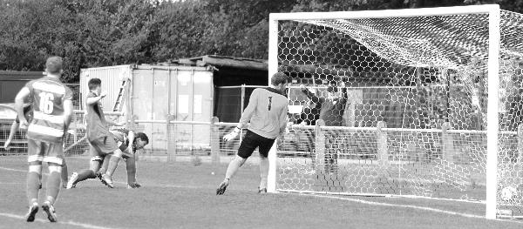
It was not ideal preparation for one of the biggest matches of the season as we travelled down the A23 to Hassocks for our F.A. Cup Extra-Preliminary Round tie but a

couple of goals from Dale Marvell put us in control at half time and he then supplied the cross to Smith to head our third (pictured left) after the home side had reduced the deficit. In truth it was a comfortable win against our Sussex opponents.

We then had a rather poor Bank Holiday weekend, both for results and for weather as we trailed twice at Colliers Wood only for Ali Dewar to bring us level twice before we conceded an injury time winner. On the Monday morning we trailed Horley Town twice in monsoon conditions but fought back to equalise twice again and this time we held on for the point despite the dismissal of Ben Hayward; our first of what would become a club record eleven this season, obliterating our previous mark of seven.

Our win at Hassocks gave us a home tie with Croydon in the next round of the F.A. Cup; a venue we had already won a pre-season match at, but that day Douglin was playing for us and now he would be playing against us. It nearly didn’t matter as an acrobatic strike from Smith had put us ahead in the first half and we were three minutes away from progressing before they equalised, forcing a replay at the Croydon Arena the following Wednesday.

The replay ended disappointingly. After an even fifty five minutes Dewar put us ahead with a rocket from the edge of the area, yet instead of pushing on we found ourselves three-one down just five minutes later. A fourth goal added some gloss to the score line and Lyndon looked fairly fed up at the end of the game. It was understandable. The team we had put out was the youngest in the club’s history with an average age of around 22 and had potential, but lacked the experience that would have enabled us to see this tie out. We were also missing our Captain Sam Currie by this stage, following a nasty knee injury and would miss him for a large part of the season.

Whether it was for one of these reasons or other factors we will never really know, but Lyndon asked to see the Committee three days later before the kick off at Hanworth Villa to tell us that he was resigning from the following Saturday. His 406th and penultimate match in charge resulted in a stunning 5-2 win, marked mainly by a super hat trick from returning player Sam Robinson who had assumed Douglin’s role just behind the strikers and appeared to be revelling in it. Ironically it was only after the match that Lyndon told the players of his decision, so this was not an emotional response to the Croydon defeat, it was just a good performance.

The Buckwell era ended the following Saturday at home to Frimley Green and was marked by two rare occurrences; a goalless draw and a penalty save from Kyle Hough. The Committee had already decided that stability was important here and that Glyn Mandeville, who already had Managerial experience at Bookham when they were at our level, would be asked to step up from the Assistant’s position. He was more than happy to take the reins and had soon appointed former player and Coach Matt Smith to the Assistant role with further help from Steve Eacott and Alex McKay.

Glyn’s first official match in charge was mostly good. We travelled to Redding Way, home of today’s opponents for a League match and won 4-1 with two goals for Sean White early in the game to set the tone, even if one was a bit of a mishit, although you wouldn’t know it from the picture! Regrettably near the end Sam Robinson picked up a

second yellow card for a petulant kick out and would miss the first of what would eventually become fifteen games this season with a suspension.

Three days later we hit the ground with a bump at Westfield. Saturday’s hero White limped off with a nasty looking ankle injury just ten minutes into the game and we were fairly limp all night, losing 4-0 although they belied their League position and looked much better than a bottom three team that the table indicated.

On reflection I think we just had a bad day and we were back to winning ways the following Saturday. The opposition were Spelthorne Sports who had been promoted after completing an unbeaten league campaign in 2013/14 and had started with seven straight wins before drawing their eighth match in midweek. We then handed them a three-nil defeat, becoming the first team to win there since March of 2013 and providing them with their first League defeat in over a year. Dale Marvell’s header for our second goal was important as it was also his 300th appearance, only the twelfth player in history to do this. (see picture below)

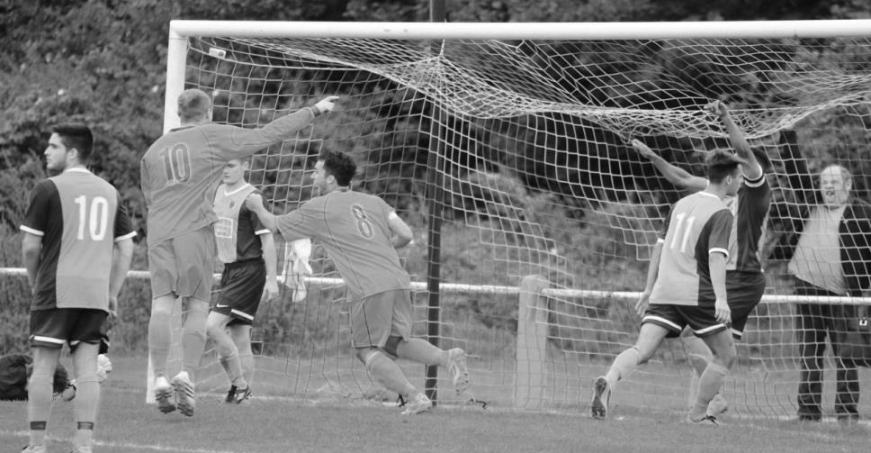
The first goal was also significant as it was Kyle Hough’s first of the season in his thirteenth appearance and he got another two three days later as we defeated an angry and disjointed Guildford City by four goals to one at High Road. It was going to be a long season for them, but it was also clear that relegation was never going to be a consideration for us, despite the budget cut. We had too much talent for that. How good could we be though?

This was going to be tough to answer for a while, although a beauty from Hough separated us and Mole Valley SCR, but on the Saturday we were quite poor as Bedfont Sports surprised us with a 1-0 win at High Road and Robinson was sent off again for a nasty challenge in the final moments of the game.

It looked like we were capable of a top ten finish if we could eliminate erratic results such as this and also eased past Knaphill in the League Cup, notable mostly for a stunning strike into the top corner from Robinson (pictured before & after across page)

but after a fairly comfortable opening set of fixtures we would finally start facing some of the title favourites.
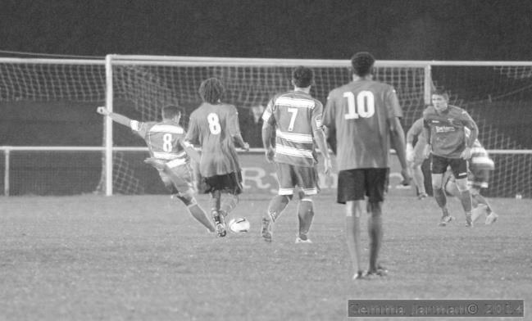
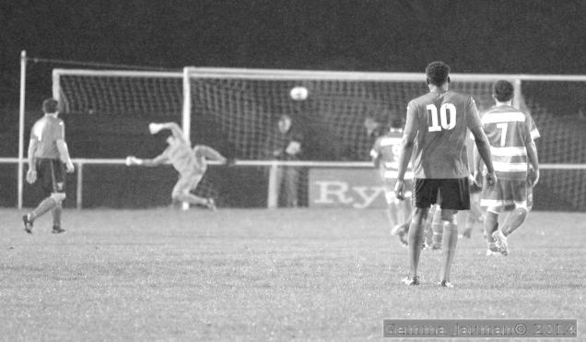
First up were Ashford Town (Mx). We usually struggled against this team and having just dropped down from the Southern League they were looking like contenders for a quick return. They defeated us 4-2 at High Road, although one of our goals was a great volleyed finish…. by their own defender! The other was scored by Matt Ferdinando who was a fairly new arrival and was just beginning to settle into the team.

The following Saturday we travelled to Krooner Park where we faced a determined and committed Camberley Town outfit. Last season’s runners up were difficult to deal with although we did fairly well, holding them to very few chances, although unfortunately they did take one of them.

If those two defeats were maybe understandable against the top two in the table, the next two defeats marked the lowest point of the season; slipping up 2-1 at home on the Tuesday night to nine man Chertsey Town, a team that had recently conceded nine goals at Molesey before we threw away our hard earned F.A. Vase exemption in a disastrous 5-1 defeat at Lingfield four days later.

I don’t know whether it is because of a greater expectation but we so often seem to produce our worst performance of the season in the F.A. Vase and this was without doubt the case this season. Moving swiftly on we desperately needed a result in our next match and got it with a 2-0 win at the Bedfont Sports Club, securing the points with two second half goals from Taylor Smith.

Unfortunately they would be the last he would score for the club as a combination of knee trouble, holidays and general reluctance to travel very far West eventually led to his departure to Horsham YMCA, assisted by now by Lyndon Buckwell. This didn’t go down well with players and staff as no official contact was made and had come two weeks after a seven day approach had been put in for Kyle Hough. Put it this way, we won’t be playing them in a pre-season friendly next season!

Anyway, back to the summary. In terms of personnel Alex McGregor returned to the club and effectively replaced Marvell who had departed for Hanworth Villa, although not until he had moved his appearance tally up past the three hundred mark.

We faced two further away trips in three days; firstly at Cove where we dominated the League leaders for large parts of the game but one defensive miscommunication cost

us as we were left to rue a number of missed chances in our 1-0 defeat. On the Tuesday we showed what could happen when we did take them in winning 5-2 at Cobham against Mole Valley SCR.

A Ferdinando header set us on our way and Hough extended the lead with the game just six minutes old. Somehow, despite our domination two goals in a quick spell had Valley level but within moments a keeper error enabled Hough to restore our lead and second half goals from Robinson and a Hough penalty, very unusually but casually struck into the top corner to complete his hat trick and ensure a comfortable victory.
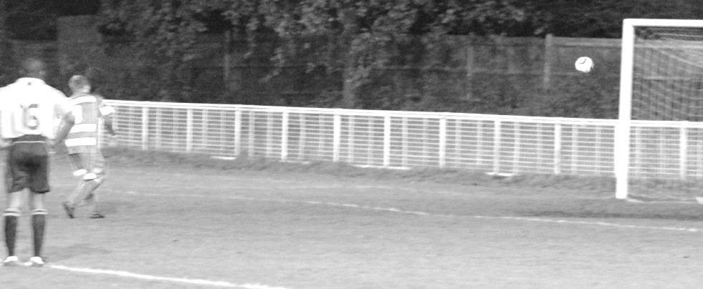
We came up against another title contender towards the end of November when we hosted Molesey. Unfortunately and a little frustratingly a slow start just four days after our flying opening at Mole Valley left us 2-0 down with just eight minutes on the clock and this was added to in the second half by a wonder strike; an overhead kick from the edge of the area by Palmer that flew in off the underside of the crossbar and a late penalty from Hough was little consolation.

A couple of Cup wins followed. We defeated Camberley Town in the Surrey Senior Cup with the only goal and the following midweek strolled past Frimley Green 5-0 in the League Cup on their own patch. Unfortunately we embarrassed them on the pitch and following a solid but fair challenge by Matt Ferdinando he found himself under attack from two frustrated players and although he was only defending himself, all three were sent off.

At least in the next match we would have Sam Robinson back from suspension, but he lasted just six minutes before reacting to a late challenge and being sent off for a third time this season. This one would cost him and the team five matches and probably three points, as even with the heavy pitch and the shortage of numbers we led twice at Badshot Lea’s temporary home ground of Ash United, both won by superb runs by Ferdinando and both penalties tucked away by Hough in the usual manner. “You’re getting closer” we said to the keeper after the second one, but he did get the last laugh as they fought back to win 4-2 as the one man advantage finally told.

On Tuesday we broke a club record but it wasn’t one to be proud of as Alex McGregor became the third player in three matches to see a red card after picking up a yellow

card for speaking out of turn. However, it led to a fantastic finalé at home to Spelthorne Sports. We were leading 2-0 at the time of the dismissal but within seconds they had a goal back. Then on the right Ferdinando robbed his man and broke for goal, smashing the ball into the opposite far corner from twenty yards. Despite this fantastic strike this game wasn’t over and the visitors pulled level with a few minutes remaining, but as they pushed for an unlikely win, we broke and it was Ferdinando again that realised he wouldn’t reach the ball as it went across goal so went to block the clearance instead and the ball flew into the net for our late winner!

Christmas came and went as it usually does, with no Epsom games due to a postponement at Raynes Park, but the New Year had been in progress for just fifteen minutes when Dan Dean was sent off for what was deemed a dangerous challenge and Windsor took full advantage, scoring four times as we tired in the final quarter of an hour to lose 5-0.

We fought back really well from this disappointment and at Ashford Town it was their turn for an early dismissal. Although we didn’t take advantage until the second half, it was a very impressive second forty-five minutes and we scored three times to silence the rather unsporting home crowd. Even when they got their consolation at 2-0 we went straight down the end and scored again. Our second goal came from Savva ‘Agi’ Panayiotou who had recently joined us and both he and Daryl Cooper-Smith had shown nice touches on their debut against Windsor. Now Agi scored a great goal, breaking through, dummying the defender and smashing the ball in.

The following Saturday it was Cooper-Smith’s turn to announce his arrival with a super low twenty yard drive at home to Farnham Town and when Alex McKay did much the same to make the score 2-2 at half time it felt as though we had escaped, having been second best for a while. However, two more goals for the visitors gave them the win and a late Surrey Senior Cup defeat at Molesey, followed by a shocking first half at home to Camberley which left us 3-0 down was very worrying.

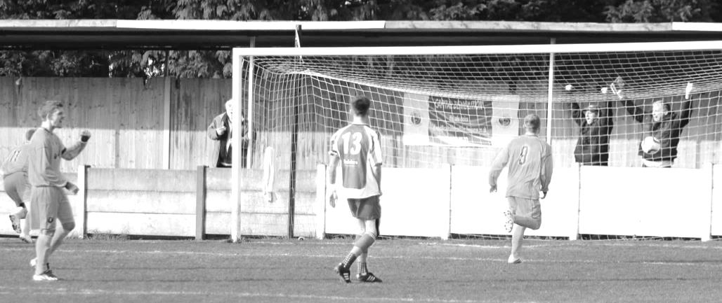
We improved to “win” the second half 2-1 though and from that point things got better. Against Hartley Wintney we showed character as we had been the better side

for much of the game yet went behind after 74 minutes. At this point Kyle Hough started an impressive run for us, scoring twice to turn the game around and give us the points and he would score in the following four matches too.

Although we went out of the League Cup against Camberley Town by four goals to two it should be remembered that we had played excellently against the leaders and had led by two goals at the half. We were able to keep that belief for a while which enabled us to secure late equalisers against Hanworth Villa and Cove before winning easily at Raynes Park Vale, although a late sending off for Dean set a new club record of eight for the year. We were already short of players and actually made no substitutions in this game as a result; only the second time in nearly five years that this had occurred.

We defeated Chertsey Town easily with goals from Cooper-Smith (pictured on previous page) and Panayiotou, although had to hang on a bit after the former received a straight red card as the resultant penalty reduced the deficit. The next Saturday Hough made up for not scoring in the Chertsey match by recording his first home hat trick for the club in our 3-0 win against Badshot Lea. It was our first in just over six years, although bizarrely we had nine away ones in that time! (third goal pictured)

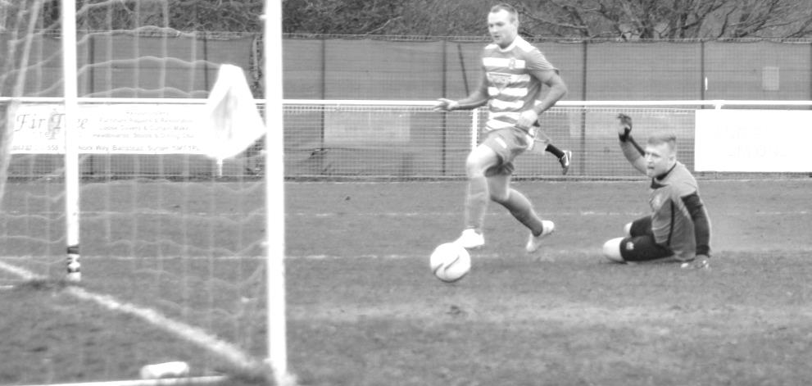
We followed this up with two 3-1 wins. The first of these at home to Westfield contained another red card for Ferdinando but a Sam Robinson strike from outside of the area clinched the points. Obviously Hough scored two goals also and he made it seven in a week with two more at the Spectrum against Guildford City, who, like us had a four game winning streak.

Our winning run extended to six against Colliers Wood United before we stalled at Horley and were flattened at Molesey, but true to form this season we have followed bad results with good ones and so it proved at Windsor as we won 3-0 in a game of many chances in the first half before we took charge in the second and won easily in the end. However, that is now three games without a goal from Hough. I think he’s lost it you know

So what were the most memorable moments this season? Mine are on the next page.

Best Performance: Our excellent 3-0 win at Spelthorne Sports in September, handing the hosts their first defeat in League action for nearly a year and a half.

Runners Up: Our 5-2 win at Hanworth Villa was superb, especially bearing in mind the manner of our F.A. Cup exit three days earlier at Croydon. For that reason I also choose our 3-0 win at Windsor last week, coming as it did after a morale sapping defeat at Molesey, while there is also a mention for a match that we lost; at Cove in November.

Worst Performance: There is only one candidate here and that is our 5-1 F.A. Vase defeat at Lingfield in November. That one still hurts.

Runner Up: A 2-1 defeat to nine man Chertsey Town in October, just three days before our trip to Lingfield. Far, far worse than the heavy defeats by Windsor and Molesey.

Best Save: Some saves are great, but some also carry extra significance because of the state of the game. For me, Michael’s low save at full stretch from close range at home to Badshot Lea in the opening minutes of the game in March could be placed in both categories. It kept us goalless in those opening minutes and enabled us to win 3-0 in the end. A tall keeper will get criticism for not getting down quickly enough at times, but this was superb and is the one that springs to mind first when we talk about saves.

Goals of the Season:
10: Savva ‘Agi’ Panayiotou v Chertsey Town (A) – Agi received the ball from a Kyle Hough left wing low cross but despite the ball being slightly behind him, he turned and swivelled, curling the ball in one movement into the far corner.
9: Sam Robinson v Westfield (A) – despite being down to ten men, Sam curled a beauty over and away from the keeper from the edge of the box. Slightly further out than his strike at Raynes Park which was very similar.
8: Matt Robinson v Molesey (A) (SSC) – Matt collected the ball around twenty yards out, cut onto his right foot and belted the ball into the net off the far post.
7: Ali Dewar v Croydon (A) (FAC) – Ali received a ball from James Taylor on the right and hit the ball first time from the edge of the area into the top corner.
6: Dale Marvell v Knaphill (A) – the second half had only just got underway but Dale spotted the keeper off his line and from fully thirty yards sent it into the top corner.
5: Kyle Hough v Mole Valley SCR (H) – Kyle looked up and saw the keeper off his line, but not by much. Still, he chipped the ball delicately over him from a long way out and it dropped just under the bar.
4: Sam Robinson v Hanworth Villa (A) – on a day of great strikes this one was started and finished by Sam as he won a header and then strolled on to the return pass to send the ball up into the roof of the net.
3: Matt Ferdinando v Spelthorne Sports (H) – we were down to ten men by this time, but this goal was a brilliant solo effort, robbing the defender and running in on goal but despite being kept wide, he hooked the ball across and over into the far top corner for a stunning finish.
2: Sam Robinson v Knaphill (H) (LC) - quite simply a superbly clean strike with hardly any backlift that never wavered and flew into the top corner, grazing the post as it went from twenty five yards (pictured earlier in the summary)

1: Matt Tanton v Hanworth Villa (A) – our left back stayed up for a corner and beat his man to reach the cross first with a powerful volley. He did really well to keep the ball down and for a defender to do it was really special. It is pictured below.

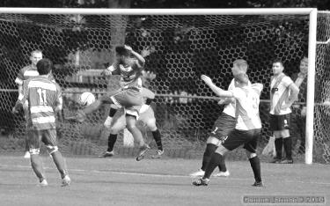

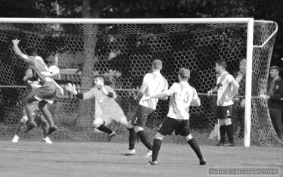

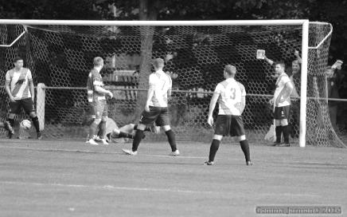

Every Opponent A-Z
Over the years we have played many, many different opponents. Exactly how many is a difficult question, as it all depends on your definition. Are Camberley & Yorktown different to Camberley Town, or are Epsom Town different to Epsom F.C. or Epsom & Ewell F.C.?

In my analysis I have classed them as the same team, and will work through them all from A to Z. Some we have played many times, whilst others we have met just once or twice. Enjoy!


Northampton Nomads: Played 1 - W1 D0 L0 - F4 A3 - PPG - 3.00 - Perfect

We played the Northampton Nomads, no connection to the powerful Amateur team Northern Nomads for a Boxing Day friendly match at West Street in 1935, winning 4-3. It was described as a “good-spirited” friendly, notable for a deliberate missing of a penalty by our Captain George Mackesy. I have been able to trace little about the club except that they were playing Amateur Cup ties in the early twenties but by the thirties appeared to be playing friendly matches only.

Northwood: Played 10 - W3 D1 L6 - F18 A22 - PPG - 1.00 - Poor

Chestnut Avenue is a pleasant venue situated in one of the greener areas of North West London that we visited for five League seasons back in the mid-nineties before they moved up the Isthmian League ladder.

They joined as London Spartan League Champions and our first meeting came on 19th September 1992 where we lost to a first half goal and in the return; their one and only visit to West Street they won impressively 5-2 in February of 1993.

Despite moving to Merland Rise for the following season, they won by exactly the same score in the September of 1993 although this time we won 4-2 over there in the December with a couple of goals from Nigel Webb and one each from Ray Purvis and Kevin Smith.

Our next visit ended in a goalless draw although we finally won at home, this time 2-0 with a brace from Stuart Miller.

In the 1995/96 season goals from Paul Meredith and Andy Boxall were not enough as we conceded four times but Boxall scored again in the return and Andy Rawlinson and Ben Forey ensured that the final day of the season would be a good one as we triumphed 3-0 at Merland Rise.

The final season resulted in two defeats despite being level at half time and in the final meeting Nick Cawthorne, one of the few players to graduate from the Epsom & Ewell Supporters F.C. actually put us ahead but we could not hold on and we lost 2-1 there on 15th March 1997.

It must be noted that any positive result against them was significant as in their time in Division Three they finished sixth, ninth, fourth, sixth again and finally third so they were perennially one of the better sides and finally reached the lofty heights of the

Isthmian League Premier Division.

Nowadays they have dropped back down to a more manageable level and ply their trade in the Southern League Central Division at Step Four where it looks as though they will finish ninth this season.

It is interesting to note (well, for me anyway!) that all ten of our matches were played on a Saturday, with not a single postponement!

The main stand and a bit of cover at the picturesque Chestnut Avenue
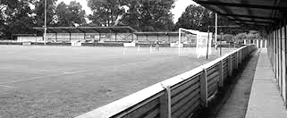
Nunhead: Held over until next season

Old Hamptonians: Played 1 - W1 D0 L0 - F4 A0 - PPG - 3.00 - Perfect

Many will recall our recent Southern Combination Cup tie at home to Old Hamptonians, an Amateur Football Combination team that play near Hampton School in Middlesex. Of course we met them at High Road, eventually breaking their stubborn resistance after 70 minutes and winning 4-0 in the end back in February 2014 but it was a lot closer than that for quite a while. They currently top the Combination and may clinch the title on May 2nd so if you are looking for a new ground to visit that is not far away, that would be my recommendation!

Old Suttonians: Played 2 - W2 D0 L0 - F5 A1 - PPG - 3.00 - Perfect

The only other old boys team we have faced, we met twice in November 1968 and again in November 1969 when paired together in the Surrey Senior Cup. The first match was played at Bourne Way, Sutton; a venue that was within 400 metres of Sutton United’s ground but is now covered by housing. We won there 3-1 with two goals from Rodger Malyon and one from Alan Parrott and the following season won 2-0 at West Street with goals from Dave Morrish and Sean Smyth.

However, our clubs have a greater link. Former Old Suttonians Secretary Hugh Bradley was a founder member and had the original idea for the Sutton & District League which commenced in 1920 and still exists today. We met as junior clubs from 1920-23 and the visionary Bradley became our Chairman from 1923 until 1928 before passing away in Derbyshire in December of 1975 at the age of 79. From the research I have carried out, it is clear that without his input and drive, we would not be here today.

From behind the goal
Molesey 5-0 Epsom & Ewell
Combined Counties League - Premier Division - Wednesday 8th April 2015

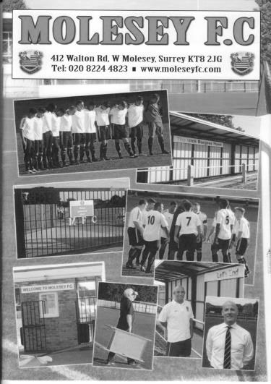
Salts smashed by rampant Moles

If anyone is wondering what a rampant mole looks like, they needed to be present at Walton Road on Wednesday evening, where we suffered our joint heaviest defeat of the season, equalling the home defeat to Windsor in January. However, while there were some mitigating circumstances that day, like an early sending off and four late goals as we ran out of steam, here there were no such redeeming factors.

A large number of spectators, including a number from Camberley Town, attended in hope and maybe even expectation that Molesey could drop some more points after their disastrous Easter weekend that had seen them lose to Hanworth Villa and Mole Valley SCR; both teams that on paper most would have expected the Moles to beat. However, they chose this particular evening to rebound from those performances and produce some top quality football, leaving us very little by way of consolation from the entire evening. From an Epsom perspective, we had gone from facing an opponent on Monday in Horley that had gone about a game plan of trying to stop us playing, to an opponent in this match that didn't care about us and concentrated on their own strengths, of which they had many, despite the absence of leading scorer Stafford Palmer.

As regular readers know I stand at the far end so it is difficult to go into much detail about the first twenty minutes of the game as much was at the other end! An early sighter was hooked just beyond our far post as early as the third minute while Michael Eacott was down smartly to smother a close range effort a couple of minutes later. We did have an opportunity after 13 minutes when Kyle Hough was put through. For a moment it looked like our in-form striker was going to lob the keeper Liam Allen, although he was quite a way out from goal and instead chose to take it round him. However, by this stage he was a bit wider and instead of shooting, crossed low for the incoming Matt Farrell but he scuffed his shot at goal and the defenders cleared. What we didn't realise at the time was that this would prove to be our best opportunity of the match.

The home side continued to press and took the lead in the 20th minute when their striker got around James Taylor and then promptly fell over. Even appeals from the home side were muted, considering the importance of the game, but the referee decided it was a foul, although interestingly chose not to award any card to our player. Matt Baxter then scored clinically from the spot. It was a deserved lead, even if the circumstances were hard to take and various shots continued to rain in on our goal. Eacott did well to clear a free header from a corner, while another ball in from the right was misjudged by Anthony Panayi,

although with the striker then through on goal Eacott stood his ground and saved well.

Some good interplay between Sam Robinson and Hough enabled the latter to get a shot away but he didn't catch the ball well enough and the attempt resulted in an easy save rather than the far top corner wonder strike that he was aiming for. Within a minute we were counting the cost as we conceded again. However, if there is ever such a thing as a good goal to concede, this was it. A poor back pass enabled the Molesey striker to get through on goal from the left and in cutting back onto his right foot, Eacott brought him down. Many officials would have blown the whistle at that point and awarded the penalty, but this one played a great advantage and the ball across was knocked in from close range by Reus Stanislaus with 37 minutes on the clock. Seeing as Eacott picked up a yellow card for his foul it is clear to me that had a penalty been awarded he would have been sent off, so bearing this in mind a 2-0 score line was the best outcome!

During the build-up to the goal Captain Sam Currie picked up an injury and he was replaced by Savva 'Agi' Panayiotou with Dan Dean taking the arm band on. However we were soon in further trouble as the hosts scored once more straight after we had threatened; Sam Robinson getting fouled but just about staying on his feet although not managing to get a cross over, this should have been pulled back for an Epsom free kick, but from the break a ball through appeared to slip under Alex McKay's foot and James McShane nipped in to knock the ball past the exposed Eacott in the 45th minute.

So by half time we had generated just three half chances but the opposition already had three goals in their locker and regrettably worse was to come. After 48 minutes a really good sweeping move from left to right was headed back into the path of Baxter who finished easily and after 59 minutes substitute and former Salt Dre Grobler finished off another move which had cut us to ribbons for their fifth goal.

Fortunately the worst was over by this point and we played out the final half an hour without any more damage. In fact the latter period was more even, although they still provided many threats, particularly from the impressive James McShane who gave us more trouble than any player all season. The real question after this display and with no offence to the teams that beat them over Easter was, how did they manage to do it?

We have now played Molesey on three occasions and have met their title rivals Camberley four times this year. Either would be worthy winners of this league but I have to say that Molesey have the greater invention and style, and assuming that they continue to play like this, the title will be theirs, despite the catching up they still have to do to overhaul the Krooners.

For our part I thought that we never gave up, despite being comprehensively outplayed for much of the match; Farrell in particular chased everything down constantly and Eacott did the best he could to prevent a heavier score line, while we also saw a return to the field of play for both George Murphy and Harry Hoadley and both fitted in well so it wasn't all bad news. But it mostly was!

Team: Michael Eacott, James Taylor, Steve Rowe, Anthony Panayi, Alex McKay, Daryl Cooper-Smith, Matt Farrell, Dan Dean, Kyle Hough, Sam Robinson, Sam Currie ©

Subs: Savva Panayiotou for Currie (37), George Murphy for Panayi (54), Harry Hoadley for McKay (73)

Centre page for results

Centre page for results

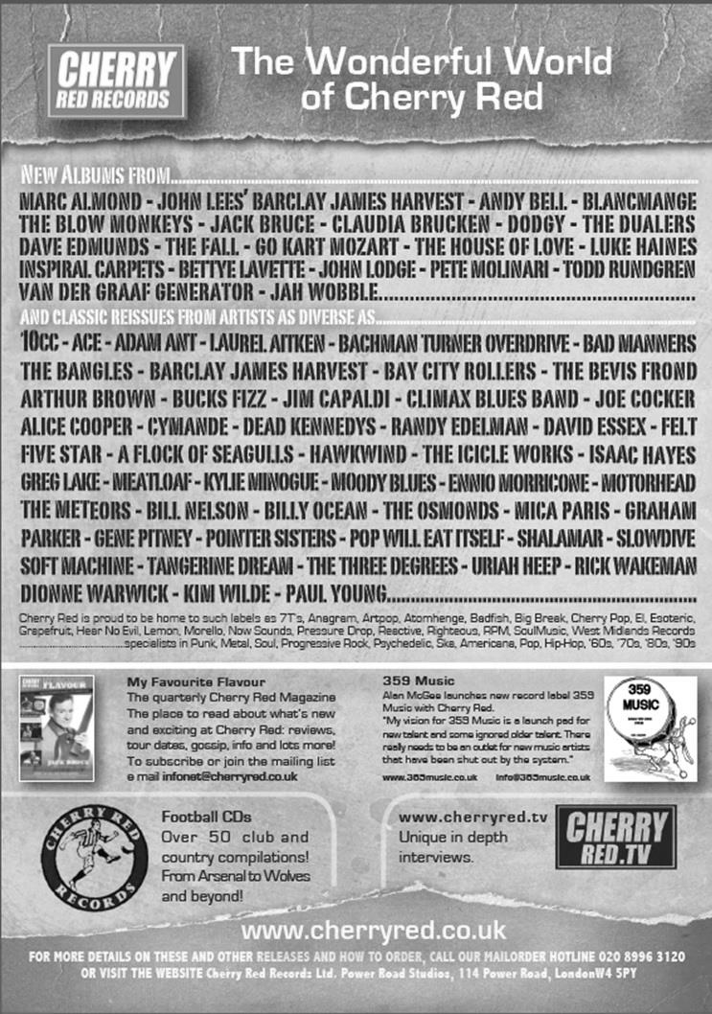



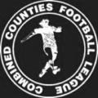

Combined Counties League

Premier Division FORM Table

Last Twelve Games | W | D | L | F | A | Pts | GD | H | A
Epsom & Ewell | 8 | 2 | 2 | 23 | 14 | 26 | +9 | - | -
Molesey | 8 | 1 | 3 | 29 | 12 | 25 | +17 | 1-3 | 0-5
Camberley Town | 6 | 4 | 2 | 21 | 11 | 22 | +10 | 3-0 | 2-4
Cove | 6 | 3 | 3 | 27 | 17 | 21 | +10 | 2-4 | 3-1
Ashford Town (Mx) | 6 | 3 | 3 | 28 | 21 | 21 | +7 | 4-1 | 3-1
Hanworth Villa | 6 | 3 | 3 | 20 | 15 | 21 | +5 | 2-4 | 0-1
Horley Town | 6 | 3 | 3 | 20 | 18 | 21 | +2 | 2-2 | 0-1
Westfield | 5 | 5 | 2 | 23 | 14 | 20 | +9 | 1-1 | 5-2
Badshot Lea | 6 | 1 | 5 | 17 | 10 | 19 | +7 | 2-2 | 0-1
Knaphill | 5 | 1 | 6 | 23 | 20 | 16 | +3 | 3-1 | 0-4
Colliers Wood United | 4 | 4 | 4 | 22 | 19 | 16 | +3 | 0-0 | 25/4
Guildford City | 5 | 1 | 6 | 24 | 27 | 16 | -3 | 0-1 | 2-0
Raynes Park Vale | 4 | 3 | 5 | 15 | 18 | 15 | -3 | 0-5 | 3-0
Spelthorne Sports | 4 | 2 | 6 | 13 | 21 | 14 | -8 | 2-1 | 2-3
Farnham Town | 4 | 2 | 6 | 14 | 27 | 14 | -13 | 1-2 | 2-1
Windsor | 4 | 1 | 7 | 24 | 23 | 13 | 1 | 4-3 | 3-0
Frimley Green | 4 | 1 | 7 | 17 | 24 | 13 | -7 | 2-1 | 1-2
Chertsey Town | 3 | 2 | 7 | 25 | 38 | 11 | -13 | 2-4 | 2-0
Hartley Wintney | 3 | 1 | 8 | 19 | 30 | 10 | -11 | 18/4 | 4-1
Bedfont Sports | 3 | 1 | 8 | 13 | 24 | 10 | -11 | 0-1 | 2-0
Mole Valley SCR | 1 | 1 | 10 | 11 | 33 | 4 | -22 | 1-0 | 5-2
We may have lost two games recently, but so has almost everyone else in this topsy turvy season!

And over the last twelve games we are looking down on the rest of the League. It just shows what we are capable of if we can take our recent form into next season. Well done lads!

Results Grid
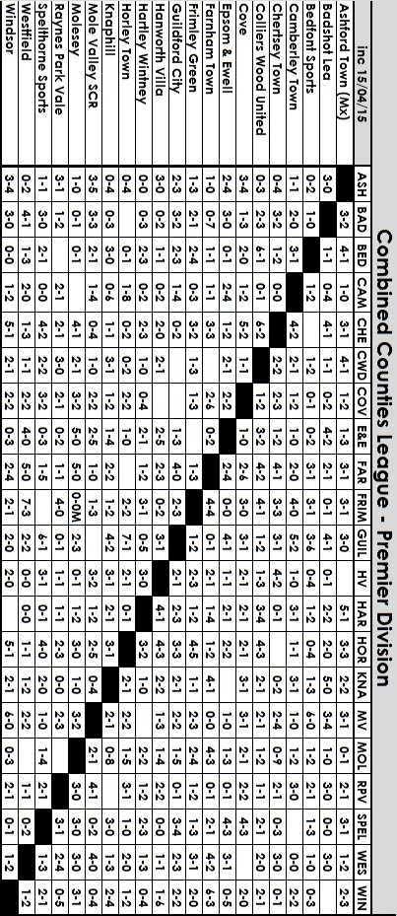

Club Records - 18th April
Date | Day | Competition |  | Opponents |  | Scorers
18/04/25 | Sat | Friendly | H | Sutton United | 2-5 | R.Marlow, T.Kirk
18/04/27 | Mon | Friendly | A | Sutton United | 2-6 | F.Ryding, C.Davis
18/04/30 | Fri | London League | H | Dagenham Town | 0-0
18/04/31 | Sat | London League | A | Finchley | 0-2
18/04/36 | Sat | London League | A | Tilbury | 0-3
18/04/38 | Mon | London League | H | Walton on Thames | 2-0 | J.Jones, T.Rochester
18/04/49 | Mon | London League | H | Guildford City Reserves | 4-1 | B.Cutter (2), E.Watkins, N.Griffiths (pen)
18/04/51 | Wed | Friendly | H | Leatherhead | 2-2 | B.Musto, T.Wright
18/04/53 | Sat | Corinthian League | H | Worthing | 5-1 | F.Lee (2), S.Scott (2), B.Goddard
18/04/59 | Sat | Friendly | H | Sutton United | 3-3 | T.Millard (2), S.Law
18/04/60 | Mon | Corinthian League | A | Wokingham Town | 3-1 | S.Dunwoody, B.Hawkins, T.Millard
18/04/70 | Sat | Athenian League 2 | H | Harrow Borough | 4-0 | B.Hartley (2), E.Sorensen, A.Payne
18/04/78 | Tue | Isthmian League 2 | A | Cheshunt | 1-2 | G.Archer
18/04/81 | Sat | Isthmian League 1 | A | Clapton | 1-3 | T.Tuite
18/04/84 | Wed | Isthmian League 1 | A | Chesham United | 4-2 | S.Milton (2), T.Boorman, R.Lewis
18/04/87 | Sat | Isthmian League 1 | H | Billericay Town | 2-0 | J.Rains, M.Elliott
18/04/92 | Sat | Isthmian League 3 | A | Hampton | 0-3
18/04/98 | Sat | Isthmian League 3 | H | Lewes | 4-0 | S.Smith (pen), P.Bunter, A.Nimmo, A.Boxall
18/04/01 | Wed | Isthmian League 3 | H | Flackwell Heath | 1-1 | M.Kempster
18/04/09 | Sat | Combined Counties  Premier Division | A | Bedfont Green | 2-4 | R.Burns, K.Hough (pen)
Historical Decades
90 years ago – Epsom Town
18/04/25 | Sat | Friendly | H | Sutton United | 2-5 | R.Marlow, T.Kirk
80 years ago – Epsom F.C.
19/04/35 | Fri | London League | A | Tooting & Mitcham U | 3-1 | H.Pullen, J.Jones, G.Collins
60 years ago – Epsom F.C.
16/04/55 | Sat | Corinthian League | A | Tilbury | 1-2 | L.Peake
50 years ago – Epsom & Ewell
17/04/65 | Sat | Athenian League 1 | H | Hertford Town | 4-1 | S.Dunwoody (2), J.O'Shea, D.Bruce
40 years ago – Epsom & Ewell
19/04/75 | Sat | F.A. Vase Final | N | Hoddesdon Town | 1-2 | T.Wales
30 years ago – Epsom & Ewell
20/04/85 | Sat | Isthmian League  Premier Division | H | Barking | 0-1
20 years ago – Epsom & Ewell
19/04/95 | Wed | Southern Comb. Cup SF | A | Chertsey Town | 0-1
10 years ago – Epsom & Ewell
16/04/05 | Sat | Isthmian League 2 | A | Flackwell Heath | 1-2 | M.Owen

Forty Years ago tomorrow!
From 1974 the F.A. Vase had replaced the Amateur Cup, following the F.A. decision to abolish the term “Amateur”. For many years previously players would find additional payments in their football boots, coining the term “boot money” and Epsom were no different. Even back in the thirties we were able to get great players to come to Epsom from depressed areas like South Wales or the North East with the promise of work.

Over time, clubs who were truly amateur were up against less scrupulous clubs as more money came into the game with the abolition of the maximum wage in January 1961. Whilst many were professional Southern League outfits, so called smaller clubs like Skelmersdale were accused of running a virtually full time operation around the time of their Wembley visits in 1967 and 1971 and although the F.A. had created the F.A. Trophy to run for the professional non-league clubs from 1970, it was not difficult to see which of the two competitions would provide the easiest route to a big day out.

A view of the West Street end in the mid Seventies. Note the covered area to
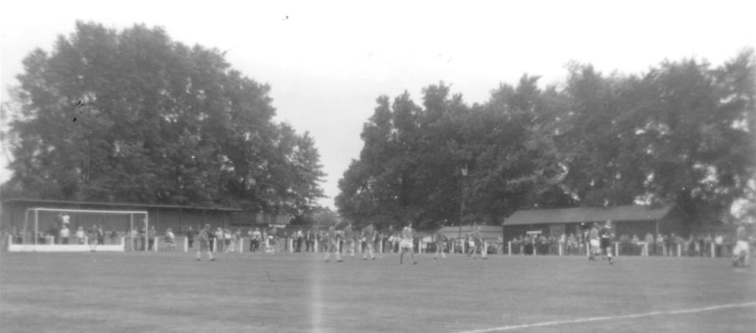
the left where the newer Clubhouse would be situated a few years later.

The Final Amateur Cup was an all Isthmian League affair, won by Bishops Stortford by four goals to one over Ilford and the competition was consigned to history after 90 years to be replaced by one that would dovetail with the Trophy based on the playing levels of the clubs that entered.

This is where we enter the story. Although in 1974/75 we had a very good side, the Vase wouldn’t have been a priority as the main task was to win the League and return to the Athenian fold, but we lined up for our first round match against tiny Reigate Priory with the intention of winning the game in the same way as any other. Priory were a team that had been one of the big names back when the Amateur Cup truly was amateur, but by remaining so had been left behind and even as long ago as 1935 Epsom had battered them 13-1 to set a club record win that still stands today.

On Saturday 26th October 1974 we eased to a 4-0 win with two goals in each half. Our Line Up that day was: Chris Page, Willie Bennett, Alan Webb, Dave Worby, Steve Jones, Phil Walker, Trevor Wales, Tommy Tuite, Dave Ritman, Johnny Eales and Trevor Lee.

Scorers: Eales (2), Worby, Walker

With exception of Player Manager Pat O’Connell coming in for Dave Ritman who would be substitute on the day of the Final, the team was already set and on a Wednesday evening we met Horley Town for the first time, recording the first of what is now twelve away wins in fifteen games against them with a 2-0 win.

However, this game wasn’t played in Horley as two attempts had been made on 16th and 23rd November but the pitch at their old ground, the Defence, was waterlogged so the game eventually took place on a Wednesday evening at Walton Road, home of Molesey, a club with floodlighting.

Goals from Tuite and Wales in the second half saw us through to the third round of the competition. Line Up: Chris Page, Keith Knight, Alan Webb, Trevor Wales, Dave Worby, Steve Jones, Ted Yorke, Tommy Tuite, Dave Ritman, Johnny Eales and Trevor Lee. Sub: Pat O’Connell for Ritman

Now the revenge process started. We had been a poor Athenian League side for many years in the late 60's and early 70's, and despite the debts of the club being cleared in 1973, the Athenian League had still rejected our membership and sent us off to the Surrey Senior League. Our next opponents on Saturday 7th December 1974 were Worthing; regular opponents during those dark days, and they were first in line for O'Connell's young side to prove that they were indeed good enough to return to the Athenian League, which was still the main goal for the season.

Worthing were trounced 4-1 on their own pitch at Woodside Road with a goal for our Player-Manager, along with two from Tuite, and another from defender Alan Webb, who was the only regular to remain from the Athenian League days.

Line Up: Chris Page, Keith Knight, Alan Webb, Trevor Wales, Dave Worby, Steve Jones, Ted Yorke, Tommy Tuite, Pat O’Connell, Dave Ritman and Trevor Lee. Sub: Micky Dunne for Yorke

It was at this point that the weather started to affect the competition. Already progressing in both League Cups and the Surrey Senior Cup, the League matches were starting to pile up. Still, the draw had been kind, geographically at least, as we could have been drawn anywhere in the country but only had to travel as far as Eastbourne.

Although the opponents were Eastbourne Town, the Saffrons was waterlogged on both 18th and 25th of January, and when it was apparent that it wouldn’t be played on Saturday 1st February either, the match was switched to Eastbourne United’s Princes Park ground for the Monday 3rd February, again due to the availability of floodlights there and we won 2-0 with goals from Trevor Lee and Tommy Tuite, one in each half. The Line Up was: Chris Page, Willie Bennett, Alan Webb, Trevor Wales, Dave Worby, Steve Jones, Pat O’Connell, Tommy Tuite, Johnny Eales, Phil Walker and Trevor Lee. This would in due course be our Vase Final eleven too.

There was no time to celebrate, as five days later the next round was to be played, with another Athenian League outfit in Hornchurch being defeated at home by a solitary Phil Walker header on Saturday 8th February. Line Up: Chris Page, Willie Bennett, Alan

Webb, Trevor Wales, Dave Worby, Steve Jones, Pat O’Connell, Tommy Tuite, Johnny Eales, Phil Walker and Trevor Lee. Sub Ted Yorke for Eales. (see picture below)

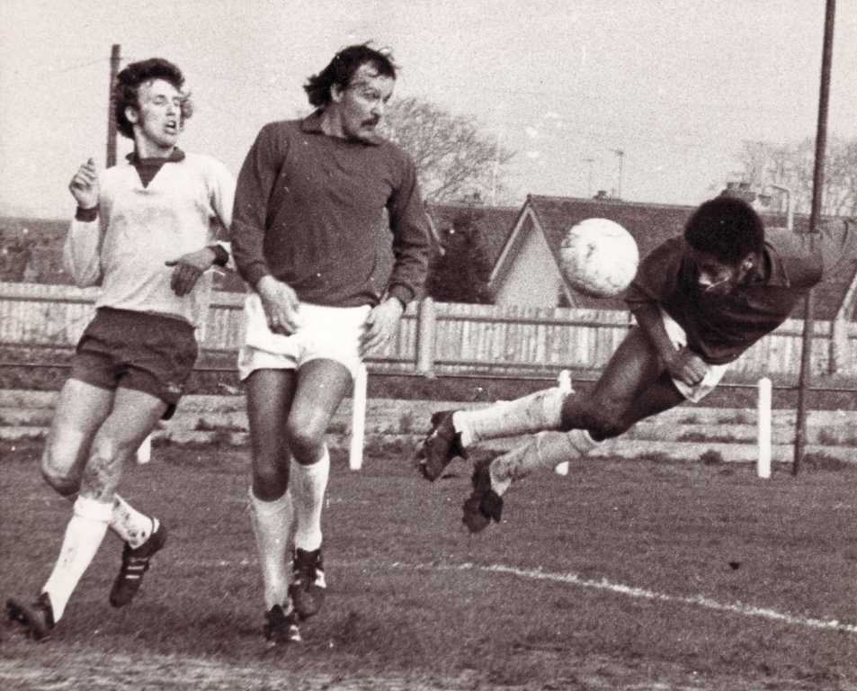

We were into the Quarter Finals and received another home tie as a reward, being paired with Addlestone at home. Addlestone, like Hornchurch before them, had been considered favourites for the competition, and had in fact beaten us in the Surrey Senior Cup 4-3 at Liberty Lane in January, although from 4-0 down, the players had fought back and gave the message that they would not be intimidated should they meet again.

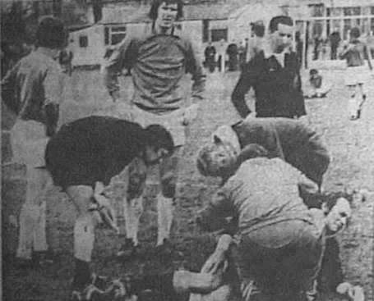
That day had come, and a goal in each half from Tuite and Wales saw another clean sheet, and a 2-0 win on Saturday 1st March. This game was also memorable for an incident where the referee collided with Dave Worby and was knocked out (see picture right, Worby is standing in the middle of the picture), so he picked up the whistle to stop the game. The referee was fine in the end, although unable to complete the match and a Linesman took over the duties.

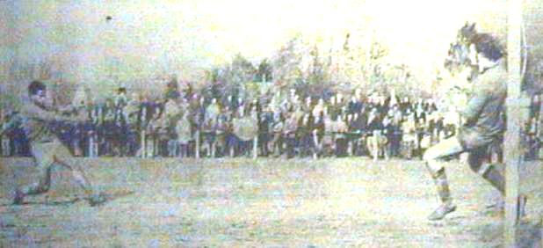
Line Up: Chris Page, Willie Bennett, Alan Webb, Trevor Wales, Dave Worby, Steve Jones, Pat O’Connell, Tommy Tuite, Dave Ritman, Phil Walker and Trevor Lee. Sub Ted Yorke for Jones

Epsom & Ewell were in the Semi-Finals. On Saturday, 22nd March 1975 we hosted United Counties League club Stamford in front of 1,604 spectators, and trailed by a goal at half-time. However, an early equaliser in the second half by Trevor Lee set the tie up,

and Phil Walker scored the winning goal with 12 minutes left (see picture above). This was followed by a nervous trip to Stamford the following Saturday, where Epsom held out 0-0 in front of 2,500 to take the tie on aggregate.
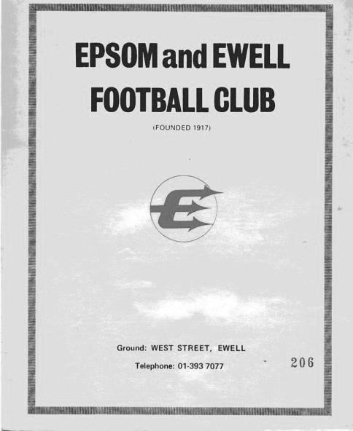
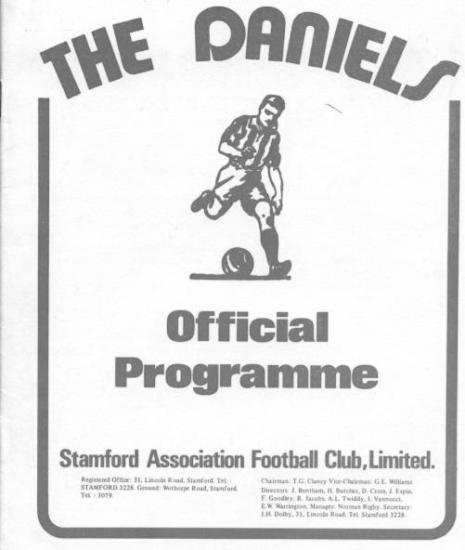
The match programmes from the Semi-Finals

First Leg: Chris Page, Willie Bennett, Alan Webb, Trevor Wales, Dave Worby, Steve Jones, Pat O’Connell, Tommy Tuite, Dave Ritman, Phil Walker and Trevor Lee. Sub Johnny Eales for Ritman

Second Leg: Chris Page, Willie Bennett, Alan Webb, Trevor Wales, Dave Worby, Steve Jones, Pat O’Connell, Tommy Tuite, Johnny Eales, Phil Walker and Trevor Lee.
Epsom & Ewell v Stamford - March 22nd 1975 - Trevor Wales and Pat O’Connell walk off the West Street pitch after our first leg 2-1 win.

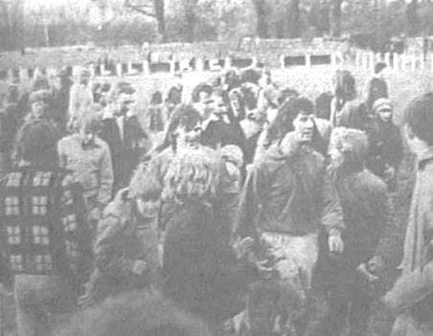
Of course, we all know that the Final ended in a narrow defeat to Hoddesdon Town, but our supporters got the chance to visit the old stadium and witness a great day out, even if things didn’t go our way on the day. The story would have a happy ending for Stamford too, as they would eventually visit Wembley twice themselves, winning the competition in 1980.

The Line Up for the Final was: Chris Page, Willie Bennett, Alan Webb, Trevor Wales, Dave Worby, Steve Jones, Pat O'Connell, Tommy Tuite, Johnny Eales, Phil Walker and Trevor Lee. Sub: Dave Ritman for Webb.

Below Left: A copy of the Match Programme at Wembley Stadium.
Below Right: The F.A. Vase Medal awarded to Epsom’s Captain Trevor Wales

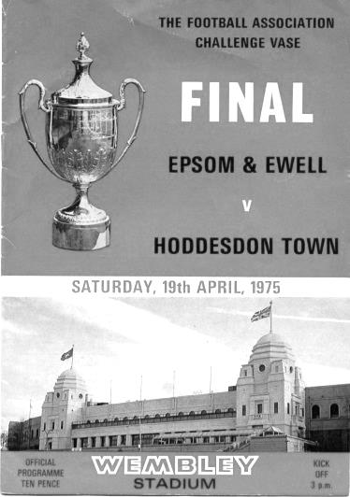
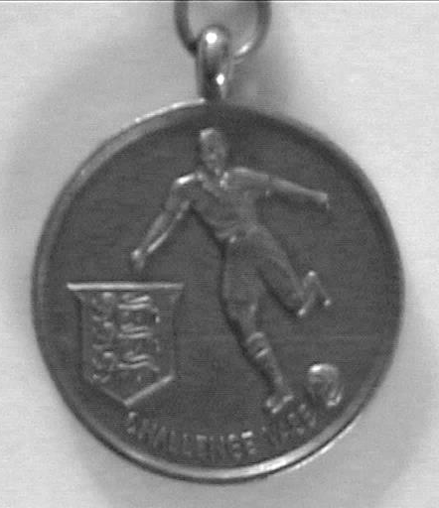

From behind the goal
Windsor 0-3 Epsom & Ewell
Combined Counties League - Premier Division - Saturday 11th April 2015

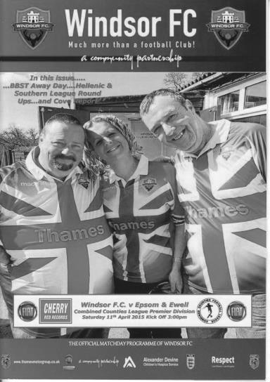
Salts hunt Stags down - in the end!

Resilience is something we have seen a lot of this season across the entire league. Many teams at the bottom have found real form and this means that every game in this league is difficult. You have to be able to put a run together by writing off the bad results and bouncing back strongly. On Saturday it was our turn to show some of that quality as we were able to consign the last two defeats to the history books and get back to the sort of form that had produced six straight wins.

Having said that, it took quite a while before we were able to be certain of all three points at the always picturesque but strangely muted Stag Meadow, as a result of a wild first half that could have ended 4-4! however, the second half was much more in our favour and chances taken by us ensured that the three points on offer were heading our way for the second year in a row, with the bonus of our biggest win here since an incredible Isthmian Premier League 5-2 demolition on a balmy Wednesday evening exactly thirty years and one day previously!

For the first time in weeks we actually had nobody suspended, although Captain Sam Currie joined Matt Robinson and Ali Dewar on the injured list after his injury at Molesey. Matt Smith, in charge due to the absence through work of Glyn Mandeville changed the selection about at the back where George Murphy came in for his first start since before his operation and Captain Dan Dean moved alongside him, moving Alex McKay to left back with Steve Rowe and Anthony Panayi dropping to the bench. In midfield Savva 'Agi' Panayiotou came back into the starting eleven, having come on for Currie at Walton Road, although his role was in Dean's vacated position alongside Matt Farrell instead of out on the wing this time.

There really were so many opportunities in the opening forty five minutes it is hard to list them all as the game swung wildly from end to end. In fact straight from the kick off a ball through to a home striker enabled him to get a shot in which Michael Eacott saved at full stretch. If it could have been 1-0 inside twenty seconds we could have been 2-1 up after three minutes as Daryl Cooper-Smith pulled a shot into the side netting before Kyle Hough put Matt Ferdinando through and his lob bounced down and up off the far post. In the fifth minute we were all at sea and required a large row Z clearance from inside our six yard box to clear the danger before a far post header from one of many corners was straight at the grateful Eacott. It was clearly going to be an exciting match!

And it was our boys who drew first blood in the tenth minute. Hough won a corner and Sam Robinson's pinpoint delivery was met at the far post by the incoming Cooper-Smith who thumped the header into the back of the net as easy as you like. Despite this the game continued to swing back and forth; the hosts winning a number of corners, the next of which was met by another far post header across goal which was met by another leaping striker but on the stretch he couldn't

keep the header down. Eacott was well-positioned to block a shot from an angle after their striker has cut between two of our men just inside the box. Within seconds though we were attacking again and the ball was knocked through to Ferdinando again who was being pressured by a defender but managed to get a superb shot off which the keeper just got a hand to. This was enough to divert the ball onto the post and it came back into play where the danger was cleared.

We hadn't even reached the 20th minute yet although as we did Eacott had to be alert to tip another header over before a slightly humorous moment when an (unnamed) Windsor player shot at goal but sent his shot fully forty yards over the bar! From this stage though we were pushed back further and set pieces rained in. A close range shot was blocked by a defender before Eacott had to be alert to parry another which then kindly rebounded back to him off a nearby player. Maybe the hosts best chance occurred after 37 minutes when a right wing cross was pulled back but from around eight to ten yards out the finish was scuffed wide of our far post and Epsom supporters breathed again!

There was still time for both teams to pick up bookings, ours for a late challenge by McKay and theirs for preventing a quick free kick which then came in to the unmarked Cooper-Smith, who expertly controlled the ball on his chest before leaning back and slicing his shot over the bar. As the whistle went it wasn't just the players who needed a sit down; I was running short of ink!

Clearly our Manager also felt that we needed more possession and so a change was made from our 4-2-3-1 formation to a more traditional 4-4-2 but with both wide men playing narrowly. My first thought was that we were going to be leaving the flanks a bit exposed but it proved to be a clever move as the withdrawn Ferdinando was able to help Panayiotou (now on the left), Farrell and Robinson in making a second line to break through, while at the same time giving Hough more help by moving Cooper-Smith forward and alongside him.

Now as we went down the slight hill at Stag Meadow we looked more like a unit. Ten minutes in Cooper-Smith put Hough through and he laid the ball into the path of Farrell but his shot was just wide. Then in the 58th minute a Robinson free kick was headed across goal by the advanced James Taylor to Cooper-Smith who controlled the ball but as it fell and he was about to pull the trigger from six yards, a superb saving challenge took the ball away from him at the last second. It was a great clearance but the reward was absolutely nothing as from the Robinson near post corner Farrell stole in front of his marker to poke the ball in for our second goal from eight yards out.

We were in control now and another Taylor cross was half-cleared to Hough who shot agonisingly just wide of the far post and just in front of the incoming Cooper-Smith but his second goal and our third in the 76th minute came from another set piece; this time a Farrell free kick was met by Murphy and his header across goal was drilled low past the helpless keeper by Cooper-Smith. There were further chances too at both ends but they were of the half-chance variety and Eacott dealt with a couple of low shots while Hough appeared to think he was offside when he wasn't and rushed his opportunity. The final action of the match was a good block from Eacott to preserve a clean sheet that had looked so unlikely after the first quarter of the match.

If someone had said to me at that stage that Windsor would fail to score over the ninety minutes I would have been amazed. Rather disappointingly, the announcer was almost discrediting our performance by apologising for theirs (and blaming an upcoming Cup Final) before the teams had even left the pitch, but they had threatened plenty in the first half and although I believe that we were playing well and may have gone on to score more anyway, it was our half time formation change that enabled us to take control and ultimately win this match. Nice one Smudger!

Team: Michael Eacott, James Taylor, Alex McKay, George Murphy, Dan Dean (c), Matt Farrell, Savva 'Agi' Panayiotou, Daryl Cooper-Smith, Kyle Hough, Sam Robinson, Matt Ferdinando

Subs: James Kavanagh for Cooper-Smith (86), Anthony Panayi for Murphy (88)

EL Records Premier Challenge League Cup
Quarter Finals
Colliers Wood United | 3-0 | Badshot Lea
Worcester Park | 1-3 | Windsor
Epsom & Ewell | 2-4 | Camberley Town
Farnham Town | 3-2+ | Cove
Semi Finals
Colliers Wood United | 5-2+ | Farnham Town
Windsor | 1-2 | Camberley Town
Final @ Woking F.C. – Friday 1st May
Colliers Wood United | v | Camberley Town

Surrey Senior Cup
Quarter Finals
Ashford Town (Mx) | 3-1 | Westfield
Colliers Wood Utd | 0-2 | Merstham
Molesey | 2-0 | Badshot Lea
Met Police | 2-1 | Tooting & Mitcham
Semi Finals
Molesey | 1-2 | Met Police
Merstham | 4-3 | Ashford Town (Mx)
Final @ Woking F.C. – Wednesday 6th May
Merstham | v | Met Police

F.A. Vase
Semi Finals – 1st leg - 21st March
Highworth Town | 0-1 | North Shields
AFC St Austell | 0-2 | Glossop North End
Semi Finals – 2nd leg – 28th March
North Shields | 3-0 | Highworth Town
Glossop North End | 0-1 | AFC St Austell
Final @Wembley Stadium – 9th May
North Shields | V | Glossop North End
Northern League | V | North West Counties

Match and Ball Sponsorships – 2014/15
Opponent | Date | Match Sponsor | Ball Sponsor
Raynes Park Vale | 05/08/14 | Club President - Stella Lamont
Horley Town | 25/08/14 | EEFC Management Committee
Croydon (FAC) | 30/08/14 | EEFC Media Officer - Richard Lambert
Frimley Green | 13/09/14 | Dave Gaffney and friends
Guildford City | 30/09/14 | The Jarman family
Mole Valley SCR | 07/10/14 | Mark and Carmel Murphy
Bedfont Sports | 11/10/14 | Epsom & Ewell F.C. Colts
Knaphill (LC) | 14/10/14 | Geoff and Steve Dyke
Ashford Town (Mx) | 18/10/14 | The Building Shop, Bookham
Chertsey Town | 28/10/14 | In Memory of Bob Bexley
Molesey | 22/11/14 | The Cabling Crew 0208 -224 4110
Camberley Town (SSC) | 02/12/14 | In memory of Liz and Doug Burns
Spelthorne Sports | 16/12/14 | long serving supporter Paul Merritt
Windsor | 03/01/15 | Ezara Beddoe
Farnham Town | 17/01/15 | In memory of Chris Henry
Camberley Town | 07/02/15 | Former player Marvin Hough
Hartley Wintney | 21/02/15 | Steve and Geoff Dyke
Camberley Town (LC) | 24/02/15 | Epsom & Ewell Colts FC
Hanworth Villa | 03/03/15 | Jeff and Arnold Pye
Cove | 07/03/15 | The Building Shop, Bookham
Badshot Lea | 21/03/15 | Vince Romagnuolo
Westfield | 24/03/15 | Tony Ferdinando
Colliers Wood United | 04/04/15 | Nathan Lambert
Knaphill | 18/04/15 | The Eacott Family
For League, League Cup and Surrey Senior Cup Matches:

Match sponsorship - £40.00 Match ball sponsorship - £25.00.
Combined Offer of Match and Match Ball sponsorship for £55.00.

For F.A. Cup and F.A. Vase matches:

Match sponsorship - £50.00 Match ball sponsorship - £30.00.
Combined Offer of Match and Match Ball sponsorship for £65.00.
----------------------------------------------------------------------------------------------------------------------------
Sponsorship includes: (x2 for match, x3 for match and ball)

Admission, programmes, hospitality and advertising and mascot for the day (if required).

If you are interested, just speak to a Committee Member, you know where we are!
Alternatively, drop me an email at: richard.c.lambert@gmail.com

Player Sponsorship
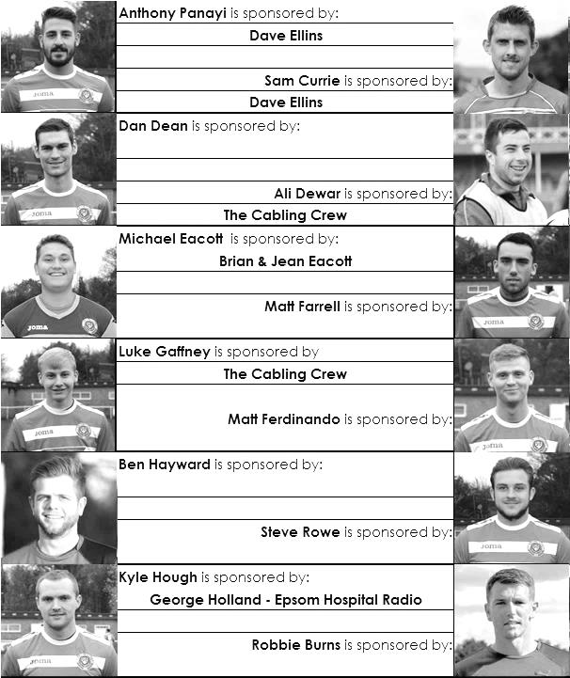

Here is the latest list showing all of the players and Management that have been sponsored this season. Thanks to all who have contributed. It all goes to help our club!

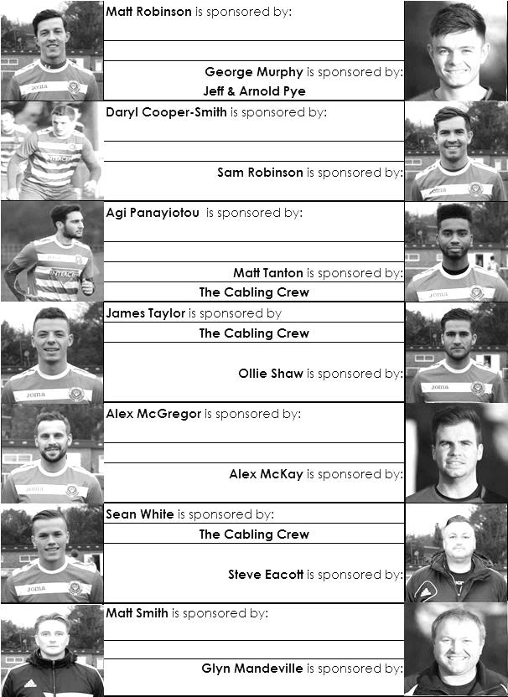

Hall of Fame - Update
Over the course of the season the Hall of Fame has had less movement than in recent years, although what we have seen has been significant.

I have to start with the passing of the 300 appearance mark. Both Dale Marvell and Kyle Hough have extended the numbers of this elite group from eleven to thirteen. Dale of course left a while back now for Hanworth Villa where amongst other things he has played in goal for them, but as it was his eighth spell with the club, it wouldn’t totally surprise me if we were to see him again at some point.

Of course Kyle remains with us and has broken his Epsom record for goals this season, currently sitting on 32, which is even more impressive when you realise that he didn’t score in his first twelve! In terms of the Hall of Fame he has jumped up into third place on our list and is now bearing down on Reg Marlow who is ‘only‘ 85 goals ahead of him!

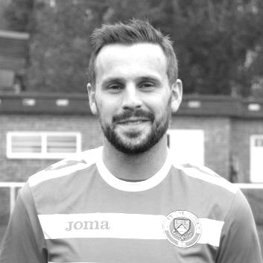
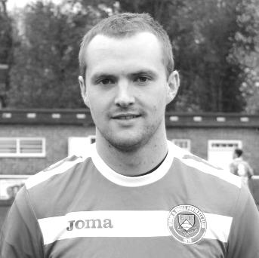
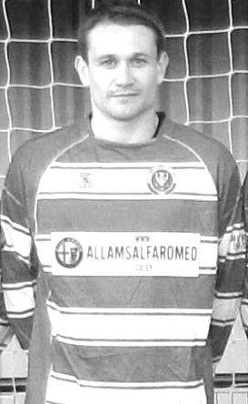
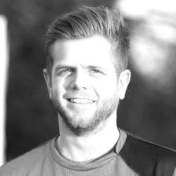
With the departures of Mark Jarman and Robbie Burns this season we have no other current players on the goals list but three more sit on the appearances table. Ben Hayward has struggled with availability this season through work commitments but at 271 appearances he site in our top twenty. Alex McGregor returned to us after a brief spell at Dorking Wanderers and is on 227, placing him in 26th position. He may join the scoring table one day, requiring six more goals to reach the top fifty.

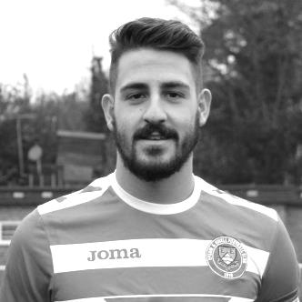
Finally, regular columnist Anthony Panayi continues to move up the list and is currently in 42nd place with 181 appearances. Anthony is the second youngest player to have made 150 appearances for the club, behind Tommy Tuite and could go substantially higher in this list with luck. Congratulations to all five players!

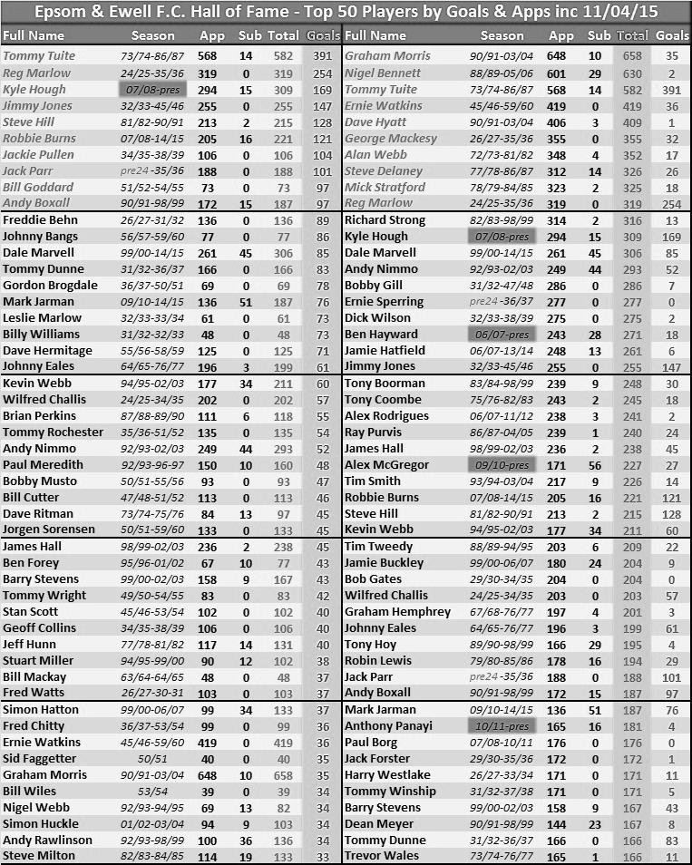

Presentation Evening
Epsom & Ewell FC will be holding an End of Season Presentation evening at the Epsom Common Working Men’s Club next Saturday, 25th April, starting from 7pm with food at around 8pm and presentations afterwards.

Tickets cost £10 and this entitles you to a choice of meal from the selection provided. We will be using one of the finest local restaurants in Epsom (ok, the fish and chip shop nearby!) and there will be a choice of various meals plus chips.

We will be presenting the Player of the Year award based on your votes, while there is also the Players Player of the Year and Manager’s Player of the Year to hand out.

We have chosen a local venue with cheap prices in the hope that many supporters will attend, so please pass the word quickly as we have to give numbers attending to the club in advance and therefore cannot accept any last minute arrivals.

Just pass your £10 to Chairman Pete Beddoe or Treasurer Steve Dyke today to secure your place.

See you there!
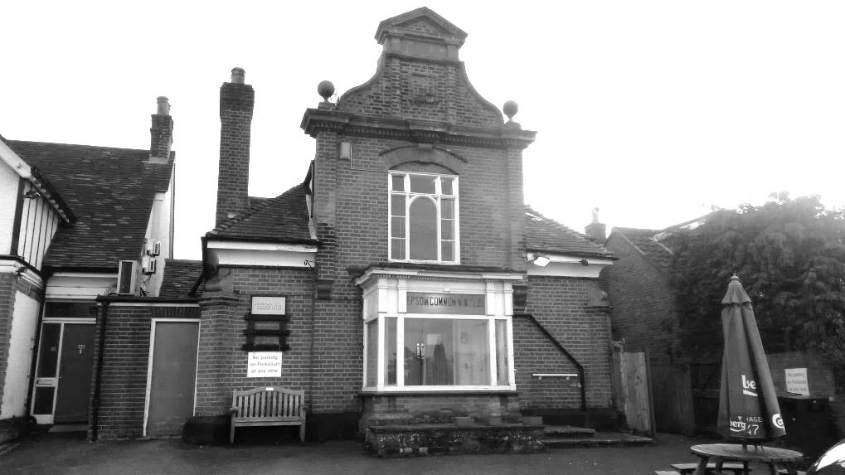

Knaphill F.C. – History
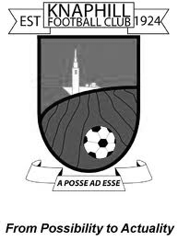
Knaphill Football Club began its life in 1924 at Waterer's Park, which was left to Woking Urban District Council in 1924 by Mr Anthony Waterer of Knaphill Nursery. The Recreation Ground was originally part of the nursery called "Blue Gates Field" and the park was laid out by Woking Council between 1924 and 1928. Very little history is known or available about the Club between 1924 and 1980. In 1980, Knaphill were represented in the Old Woking and District League (now Guildford and Woking Alliance League) in Division 3 under Manager Dave Holloway. Dave took them from Division 3 through promotion to the Surrey Intermediate League.

Mick Garbutt became the Manager of Knaphill in 1990, but in 1994 departed to join up with Colin Lippiatt and Geoff Chapple at Woking. In 1996 David Freeman took over from First Team Manager Greg Anderson, who was in charge for just one season 1995/96. Sean Carrigy was Reserve Team Manager. Season 2002/03 saw 2 new men at the helm with Mick Garbutt in charge of the 1st Team and Frank Walters the Reserves.

Season 2005/2006 was destined to be a big season for the club with the club established at new ground at Redding Way and the’ A’ team reverting back to Waterers Park having had the facilities rebuilt. 1st Team Manager David Freeman continued in charge for the 2005/2006 campaign and appointed former professional with Bristol City, Bob Pritchard, who had also managed at senior level with Chertsey Town. The 2005/2006 season did prove successful as we won the Division One title on the last day of the season against nearest rivals Virginia Water and gained promotion to the Premier Division.

2006/2007 continued with David Freeman in charge of the 1st Team who claimed back to back titles by winning the Premier Division Championship which resulted in us achieving promotion to the Combined Counties Football League, the most successful period in the clubs history up to then. Bob Pritchard took over from David Freeman as Manager who then became Bob’s assistant during September 2007. They took the team to a very commendable 7th place in the CCL, our first in senior football. Steve Hutton led the Reserves campaign, with a massive 40 games in the season.

The 2008/09 season started with former Bisley and Farnborough Assistant Manager, Ian Savage joining the Club as player/coach. The team kept a high profile in the League staying in the top half of the table all season, eventually finishing in fifth place. They could have become champions had they won their last game of the season when, in a tightly bunched set of teams in the top six. Knaphill on 69pts needed to win at Farleigh to pip Staines Lammas to the title. Disappointingly they lost 3-2, so near yet so far. The Reserves finished ninth in their Division with the second half of the season providing a 17 match sequence losing just two games. The 2009/10 season saw the team finish third in Division One, their best placing in the three seasons in the Combined Counties League. Third would normally have gained the Club promotion, but due to the proposed floodlights installation being delayed, Knaphill had to make another challenge for promotion in 2010/11. The team won 26 out of their 40 league games, losing 10 with 4 drawn, scoring 98 goals and finished with 82 points.

Season 2010/11 was one of two halves for the first team, having suffered a poor string of results in the first four months of the season, the turn of the year went onto see an unbeaten run of 12 matches. But the run was not enough to see us get close enough to a promotion place, and after reaching fifth in the table in the final run in.. The newly formed Knaphill Youth U18s, played their first season in the Allied Counties League, and reached the final of the Grant McLellan Youth Cup, but lost 2-0 to Bedfont Sports. The 2011/12 season saw Knaphill entering the FA Vase for the first time, and the team finished 12th in Division One. Our Youth team reached the Grant McLellan Cup final for the second year running, but were beaten finalists. Chairman Terry Chapman stood down as Chairman, and David Freeman, 16 years at Knaphill, took over the role in the first half of the season. Season 2012/13, the 1st team finished 12th in Division One.

So season 2013/14 emerged with Phil Ruggles as 1st team Manager, and Steve Pearman as his Assistant and players wise, many new faces in the squad, It was Knaphill’s seventh season in the Combined Counties League, and it proved to be a season that showed more progression for the Club. Promotion to the Premier Division! There was also a nice ‘mini run’ in the FA Vase with wins over Badshot Lea, Tadley Calleva and Dorking, before going out of the competition at home to East Preston. League success saw Knaphill gain promotion to the Premier Division.

The 2014/15 season brings forth a big League programme of 40 games, in comparison with just 30 matches in Division One last season. Knaphill enter the FA Cup for the first time, and continue taking part in the FA Vase, and with other Cup competitions, it’s going to be a busy 2014/15 season in progress, in this the Club’s 90th Year.

Epsom & Ewell F.C. Club History 1918 - 2014

We were founded in March 1918 as Epsom Juniors Cricket Club and played throughout the summer. In the autumn, Epsom Juniors F.C. came into being and played a handful of games from what is now known as Alexandra Recreation Ground. Competitive football followed as we entered the Surrey Junior League in 1919, and became founder members of the Sutton & District League in 1920.

A change of name in July 1922 to Epsom Town F.C. heralded the start of a very successful era. By now resident at the Horton Hospital Sports Ground, we were unfortunate to lose 2-1 after extra time at Dorking F.C.’s Pixham Lane ground to Caterham Mental Hospital in a replay of the Surrey Junior Cup Final. However, we won three other trophies that season, the Leatherhead Hospital Shield, the Sutton Hospital Cup, and the Epsom Hospital Cup. In addition, we also won the Sutton & District League, and under the forward thinking of their visionary Chairman Hugh Bradley, took the step into Intermediate Football, where we won the Southern Suburban League without losing a match. Senior football was granted as we were unanimously accepted into the Surrey Senior League for 1924/25, where we finished third.

In September 1925, the club relocated to the old Ewell F.C. ground at West Street, which was purchased through the generosity of our future President Robert Bradshaw. In 1925/26 the Championship of the Surrey Senior League was attained, and the following season, we defeated Egham 1-0 at Egham in the League Charity Cup to complete a League and Cup “double”.

Election to the London League followed, and the title was claimed in the first attempt in 1927/28. Unfortunately, we were unable to repeat this, instead finishing runners-up in 1931/32, 1932/33, 1934/35, 1936/37 and 1937/38. Cup Honours were limited, although in 1929 Redhill defeated us 3-2 in front of 4,600 at Guildford in our first Surrey Senior Cup Final, having seen off Wimbledon 4-1 in the semi-final!

The thirties were a very successful era, and we won the Surrey Charity (Senior) Shield in 1933 with an impressive 5-0 win over Woking at Kingfield. However, the proudest moment of our pre-war history was an appearance in the First Round Proper of the F.A.Cup in 1933/34. Woking, Nunhead, Tooting & Mitcham, Beddington Corner, and Leytonstone were defeated, and a crowd of 9,485 at the Lea Bridge Speedway Stadium witnessed a 4-2 loss against the hosts Clapton Orient. At the end of that season we changed our name to Epsom F.C.

In 1939 a newly formed team, Epsom Town (no connection to the earlier name) shared the ground with Epsom F.C. However, this arrangement was suspended when war was declared, and we folded for the duration. In the meantime, Club Chairman Charles Pettett threw in his lot with Epsom Town in an attempt to boost morale by keeping the football flag flying. It was successful, as that club competed continuously throughout the war years, winning the Surrey Combination in 1939/40, and reaching the Surrey Senior Cup Final in 1944, losing 3-1 to Tooting & Mitcham, at Sandy Lane. After the war, Epsom F.C. restarted, continuing in the London League and reclaimed West Street. Temporary homes were found for Epsom Town while they competed for a season in the newly created Corinthian League, but disbanded in 1946.

In 1949 we entered the Corinthian League ourselves, where in 1952 we reached the League Memorial Shield Final in 1952, going down 2-1 to Champions Hounslow at Eastbourne after leading at half-time. Things improved further with the signing of the former English Amateur International Pat Lynch from Hendon, finishing third in 1952/53, while in 1954 we reached the Surrey Senior Cup Final for the second time in our history, losing unluckily 2-0 to Corinthian Casuals in front of 6,159 at Selhurst Park. In 1955 we won the Surrey Senior Shield with a 1-0 win over Carshalton Athletic at West Street.

We appointed our first ever Manager, Kingstonian legend Doug Whitehead in 1955 and the Corinthian League double was almost achieved in 1956/57, but two losses in the final week, along with a 2-0 defeat in the Cup Final to Maidenhead United at Dorking ensured that we ended with neither, finishing fourth. However in 1960, we finally raised the Shield with a 2-0 revenge win over Maidenhead at Vale Farm, home of Wembley F.C.

In 1960 we changed our name once again to Epsom & Ewell F.C. This was not because of any merger with Ewell & Stoneleigh as is often quoted, but was an attempt to increase support across the whole of the Borough. In 1963 the Corinthian League merged with the Athenian and Delphian Leagues, and we were placed in Division One of the new structure, but the sixties were full of poor results and we were relegated in 1965.

Despite a string of managers, most notably ex-Leyton Orient winger Jimmy Smith, and Tony Williams, now famous for his creation of the F.A. Yearbooks, our fortunes did not improve significantly and further relegations were avoided in the early seventies by the benefit of re-election. However in 1973, despite “improving” to finish second from bottom, the Athenian League ran out of patience and cut us loose. This was unfortunate timing as

we had just cleared all of our debts, and in addition to a virtually new Committee, former Fulham player Pat O’Connell had taken over as Manager.

The Surrey Senior League took us in at the last minute, and the new squad, including young striker Tommy Tuite, won the League Cup, and the following season, 1974/75 achieved a second Surrey Senior League “double”. However, the season would always be remembered for reaching the Final of the inaugural F.A. Vase, where 9,500 saw the Blues edged out 2-1 by Hoddesdon Town at Wembley Stadium. The Athenian League welcomed us back, and promotion to the top flight was achieved in that first season. In 1976/77 we reached the Athenian League Cup Final, losing 1-0 at Chalfont St Peter.

For 1977/78 many clubs were invited to join the expanding Isthmian League, and we were placed in the new Division Two. Our first match under floodlights took place against Met Police, and the title was clinched the following April. In 1979/80 we won the Southern Combination Cup 7-2 over Hampton on their own pitch, where the opposition were blitzed by five goals from Tuite. The following season a new clubhouse opened at West Street, and we finally won the Surrey Senior Cup, defeating Woking 2-1 at Tooting & Mitcham, although we just missed out on promotion. In 1983/84 we clinched a spot in the Premier Division as runners-up, although this time we missed out in the Surrey Senior Cup Final, defeated 4-0 by Sutton United at Imber Court.

With Adrian Hill as Manager since 1982, we survived comfortably in our first season at the new level, but Hill’s departure to Croydon in 1985 started a decline. Much of the squad left with Hill, and new Manager Alan Webb had too much to do. We were relegated in 1986, and following Webb’s departure soon after, Player / Manager Ricky Kidd nearly but not quite saved us from our second straight relegation. Adrian Hill replaced Kidd for a second spell at the helm in 1990, but we were placed in the new Division Three in 1991 in league reorganisation following a finish one position below the required half way mark.

In 1993 a large chapter in our history ended as we left West Street and moved in as tenants of Banstead Athletic. The decade was largely one of frustration, although we did reach the Final of the Associate Members Trophy, losing 2-0 to Bedford Town at Hendon’s old Claremont Road ground.

In 2002 Adrian Hill took us back up to Division 1 South, where we topped the table for a month, eventually finishing 9th, but Hill’s retirement at the end of the season led to relegation a year later and in 2006 we were transferred into the Combined Counties League Premier Division. In October 2006 Lyndon Buckwell, a former player became our new Manager, and in his first full season (2007/08) we were back in the top ten. In 2008/09 we exceeded this achievement and finished in fourth place after heading the table for a few months. In 2009/10 the club recovered from a slow start to finish fifth and also reached the last 32 of the F.A. Vase for the first time in 21 years, bowing out 3-2 in Northamptonshire to Long Buckby. In April of 2010 we terminated our seventeen-year ground sharing agreement with Banstead Athletic and spent two unspectacular seasons at Merstham F.C. before relocating to High Road, home of Chipstead F.C. for the 2012/13 season.

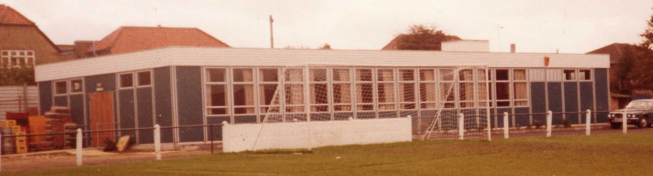
The season brought significant playing success as a slow start was followed by a spectacular run of form, including a club record 12 straight League wins, which put us at the top of the table for over a month before a tough run in resulted in a final position of fifth. However, any disappointment there was tempered by the club’s first silverware since 1981 when we defeated South Park 3-0 at Farnborough to win the Combined Counties League Cup. Lyndon also marked 300 games in charge of the club in early 2013. On a sadder note, 2012/13 also marked one thousand games and twenty seasons since we left West Street.

We carried our fine form into 2013/14 and led the league with eight straight wins but couldn’t hold on and had to settle for third place, our highest league finish since 1984, and we continue at High Road for 2014/15.

Meanwhile, the search continues for a new ground back in the Borough…..

Club Statistical History - (including Windsor match on 11/04/15):
All League: Played: 2,793, Won: 1,139, Drawn: 529, Lost: 1,125
For: 5,118, Against: 4,982, GD: plus 136 - Win Ratio 40.78%

Combined Counties League only: Played: 372, Won: 165, Drawn: 71, Lost: 136
For: 652, Against: 596, GD: plus 56 - Win Ratio 44.35%

Cup and Other: Played: 1,092, Won: 518, Drawn: 127, Lost: 439
For: 2,374, Against: 2,038, GD: plus 336 - Win Ratio 47.44%

Abandoned Matches: Played: 8: For: 14, Against: 16

Under Glyn Mandeville: Played 37, Won: 19, Drawn: 2, Lost: 16
For: 71, Against: 68, GD: plus 3 - Win Ratio 51.35%

Overall Total: Played 3,885, Won: 1,657, Drawn: 656, Lost: 1,564, Abandoned: 8
For: 7,492, Against: 7,020, GD: plus 472 - Win Ratio 42.65%

The clock ticks:
I thought I’d have a look at some important dates in our club’s history.

Taking an estimated day of foundation as 1st March 1918 (it was definitely in March but exact date unknown), we have been in existence for 35,477 days.

It is 29,729 days since we played in the F.A.Cup First Round against Clapton Orient (25/11/1933).

It is 27,621 days since the start of World War Two (03/09/1939).

It is 20,076 days since we won the Corinthian League Memorial Shield (30/04/1960).

It is 14,609 days since we appeared at Wembley Stadium in the first F.A.Vase Final (19/04/1975).

It is 13,508 days since we last won a League Title (Isthmian League Division Two –confirmed on 24/04/1978).

It is 12,416 days since we won the Surrey Senior Cup (20/04/1981).

It is 11,309 days since we earned promotion to the Isthmian League Premier Division (01/05/1984).

It is 8,017 days, (or 21 years, eleven months and twelve days) since we played our last match at West Street (06/05/1993).

On a positive note it is only 708 days since we last won a Cup Final (10/05/2013 – Combined Counties League Cup v South Park).

CCL Premier Division Club Directory
ASHFORD TOWN (Mx) Telephone: 01784-245908 - Ground: The Robert Parker Stadium, Short Lane, Stanwell. TW19 7BH - Colours: Tangerine & White Stripes/Black/Tangerine

BADSHOT LEA Telephone: 01252-320385 - Ground: Ash United FC, Shawfield Stadium, Youngs Drive, Shawfields Road, Ash, Hampshire. GU12 6RE - Colours: Claret/White/Claret

BEDFONT SPORTS Telephone: 0208-831-9067 - Ground: Bedfont Sports Club, Hatton Road, Bedfont, Middx TW14 8JA - Colours: Red & Black Hoops/Black/Red & Black Hoops

CAMBERLEY TOWN Telephone: 01276-65392 - Ground: Krooner Park, Wilton Road, Camberley, Surrey. GU15 2QW - Colours: Red & White Stripes/Blue/Red

CHERTSEY TOWN Telephone: 01932-561774 - Ground: Alwyns Lane, Chertsey, Surrey. KT16 9DW - Colours: Royal Blue & White Stripes/Royal Blue/Royal Blue

COLLIERS WOOD UNITED Telephone: 0208-942 8062 - Ground: Wibbandune Sports Ground, Lincoln Green, Opposite 199-213, Robin Hood Way, Wimbledon. SW20 0AA - Colours: Blue & Black Stripes/Black/Black

COVE Telephone: 01252-543615 - Ground: Oak Farm Fields, 7 Squirrel Lane, Cove, Farnborough, Hampshire. GU14 8PB - Colours: Yellow/Black/Yellow

EPSOM & EWELL Telephone: 01737-553250 - Ground: Chipstead FC, High Road, Chipstead, Surrey. CR5 3SF - Colours: Royal Blue & White Hoops/Royal Blue/Royal Blue & White Hoops

FARNHAM TOWN Telephone: 01252-715305 Ground: Memorial Ground, Babbs Mead, West Street, Farnham, Surrey. GU9 7DY Colours: - Claret & Sky Blue /White/ Claret & Sky Blue

FRIMLEY GREEN Telephone: 01252-835089 - Ground: Frimley Green Recreation Ground, Frimley Green Road, Frimley Green, Camberley, Surrey. GU16 6JY - Colours: Blue & White/Blue/Blue

GUILDFORD CITY Telephone: 01483-443322 - Ground: The Spectrum, Parkway, Guildford, Surrey. GU1 1UP - Colours: Red & White Stripes/Black/Black

HANWORTH VILLA Telephone: 0208-831-9391 - Ground: Rectory Meadows, Park Road, off Hounslow Road, Hanworth, Middlesex. TW13 6PN - Colours: Red & White Stripes/Black/Black

HARTLEY WINTNEY Telephone: 01252-843586 - Ground: Memorial Playing Fields, Green Lane, Hartley Wintney, Hants RG27 8DL - Colours: Orange & Black/ Orange /Orange

HORLEY TOWN Telephone: 01293-822000 - Ground: The New Defence, Anderson Way, Court Lodge Road, Horley, Surrey. RH6 8SP - Colours: Claret & Sky Blue/Claret/Claret

KNAPHILL Telephone: 01483-475150 - Ground: Brookwood Country Park, Redding Way, Lower Guildford Road, Knaphill, Surrey. GU21 2AY - Colours: Red/Black/Red

MOLE VALLEY SCR Telephone: 01932-866386 - Ground: Cobham FC, Leg O’Mutton Field, Anvil Lane, Downside Bridge Road, Cobham, Surrey KT11 1AA - Colours: Yellow/Black/Black

MOLESEY Telephone: 0208-979-4283 - Ground: 412 Walton Road, West Molesey, Surrey KT8 2JG - Colours: White/Black/Black

RAYNES PARK VALE Telephone: 020-8540-8843 - Ground: Prince Georges Playing Field, Grand Drive, Raynes Park, London. SW20 9NB - Colours: Blue/Blue/Red

SPELTHORNE SPORTS Telephone: 01932-961055 - Ground: Spelthorne Sports Club, 296 Staines Road, Ashford Common, Ashford, Middx. TW15 1RY - Colours: Light & Dark Blue/Dark Blue/Light Blue

WESTFIELD Telephone: 01483-771106 - Ground: Woking Park, Kingfield Road, Woking, Surrey. GU22 9BA - Colours: Yellow/Black/Black

WINDSOR Telephone: 01753-860656 - Ground: Stag Meadow, St Leonards Road, Windsor, Berks SL4 3DR - Colours: Red/Red/Red

My thanks!
Although I had a break from the role last season, it is now nearly eight years since I compiled my first match programme; a home game against Colliers Wood United which was also the day that Robbie Burns and Kyle Hough made their debuts.

During those years we have done fairly well on the field; not so well off it at times, and of course have played at three different venues as we attempt to return to our home Borough.


This is proving to be a very difficult challenge, although for the last season I have at least been able to add my (loud) voice to such discussions. This season we have been in regular contact with the Holding Company who are now much happier to conduct business with us, which might not have been the case a while back.

As always, our attempts have to be kept fairly guarded, and I cannot say too much following our battle to secure a site at the back of Epsom in the early part of this Century, which were public enough to enable certain groups to jump in ahead of us. As a result, the Boiler House site is now better known these days as the David Lloyd Centre.

What I will say, whilst remaining fairly vague about it, sorry, is that we are now concentrating our minds on two particular sites and have engaged the services of a consultant who has provided us with help and assistance through the latter half of this season.

We, or more relevantly, the Holding Company would not have sanctioned the cost of this if they didn’t believe that it was worthwhile, although we are all extremely conscious of the club’s finances running down while we remain away from home and need to find a way of getting a large part of this moving by August 2016 if we are to retain a realistic chance of being able to build a ground, regardless of whether we are able to confirm a site for it.

I believe this is a positive move and that an upcoming meeting of the Club Steering Committee will enable us to make some decisions and hopefully achieve more progress over the summer. I will report what I can, both here and on our web site, so please keep following the club during the close season.

Due to budget cuts this season we have been able to retain more of our money, which has been invested well enough to actually earn us some interest despite these austere times. Regrettably the days of spending money on such luxuries as a Reserve or Youth team are gone until we are back at base, although we are expecting a similar type of situation financially next season, so I am confident that we will have a playing squad that is at least as good as the one we have currently, as it is clear to me that we are not far away from mounting a challenge with the lads we have and I’m sure Glyn and Matt will be working on this during the summer.

I won’t cover the playing activities in detail as they have already been surmised in the seasonal review, but would like to quickly open up my seasonal thanks with our previous Manager Lyndon Buckwell. For those who have been on a different planet, Lyndon was our third longest serving Manager in history with 407 games in charge since he joined us in October 2006 and of course departed in September of this year. He has set the bar quite high for our current Management team who will no doubt be trying to at least emulate and maybe even surpass his achievements. He will remain a club Legend.

Away from the playing staff there are a number of people who make the club tick behind the scenes. Not as many as we would like though, and if you feel that you can help the club in any way, please let us know.

I shall start with our Chairman Pete Beddoe. Always personable and extremely patient, I have been impressed with his organisation over the course of the season. Having been more or less thrust into the role last season following the illness to Tony Jeffcoate, he took on the position officially last season and is constantly involved with club affairs. I can vouch for an enormous number of emails (sometimes at eye wateringly early times in the morning) that have flooded out over the season that have enabled myself and others on the Committee to be on the same page, which is vital when you are running a big organisation. Make no mistake; this club is still a big one with a lot of logistical challenges associated with it.

Committee meetings are shorter and more efficient as everyone knows where they stand before we go in and we are no longer fire-fighting, which gives us the chance to spend more time actually planning ahead. Again this is vital when faced with the upcoming new ground discussions and meetings, of which there are many.

By his side is our Vice Chairman Steve Dyke. I have known Steve for many years now and after a bit of miscommunication a couple of years ago, we are now back on the same page. Steve has taken on much more in recent seasons but his main success has been in bringing stability and order to our finances. In my opinion, this is maybe the most relevant reason why the Holding Company is now happier dealing with us.

As you would expect he has produced a budget, but this season has kept us informed of how we are getting on by way of regular updates at our meetings. This might sound fairly straight forward, but for whatever reasons it wasn’t being done beforehand, even back in the late eighties when I first spent time on the Committee and is a useful addition.

Steve has also been instrumental in obtaining match and player sponsorship for the club. Again, this is an area where you can help us just by coming over and confirming a sponsorship for next season as we are aiming to fill many of these slots during the close season if we can.

He has also missed a few of our goals this season whilst out of the ground fetching the match balls that are deposited there by both sides. I am fortunate in that I write the match reports so cannot leave the ground. Steve and Paul have no such luxury.

And it is Paul Marshall that I thank next. Paul was one of the first people you would see at the gate selling the Golden Goal and has now become the face of the Salts Super Six Predictor Competition. Paul also helps out in the dressing rooms, with hospitality in the Board room along with our resident helpful host Alan ‘Coops’ Cooper and like the two people I have mentioned already, rarely misses a Salts game.

Other Committee Members who have been around in the background this season are Mel Tough last season’s Reserve Team Manager who has been Membership Secretary, and has also provided a chunk of sponsorship under the guise of his company, while our link with the Colts side has been provided by Mike Lovett, although he has recently resigned as Chairman of the Colts, so we thank him for his time and wish him well in his new ventures.

Of course Glyn Mandeville has inherited the Manager’s position on the Committee following Lyndon’s resignation and hasn’t missed a meeting. Some clubs wouldn’t have a member of the playing staff on their Committee but I think it is an excellent move as it enables both sides

of the club to understand each other’s position and priorities and as a result there are no “them and us” situations at this club. Glyn has been asked to stay on next season and is already planning for the future which is good news.

Also, although not on the Committee, our club Photographer Gemma Jarman has been very dependable this season, providing supporters with numerous photos of the Salts in action to her usual high standard. I thought we would lose her this season following the departure of her son Mark as a player. Fortunately “Team Jarman” continue to follow us home and away and are very much part of our family these days.

The next person I will thank may not be known to many of you. Malcolm Shelbourne is a former Epsom player and has this season become our kit sponsor, through his company Intercem. We are very grateful for the donation of a kit this season and hope he will remain involved in future seasons.

Of course we have had many other sponsors this season, either for a match or for a player and the club are grateful for the donations. These people are already listed elsewhere.

This brings me to the supporters. We are not many in number, but we are very reliable and a number have followed us regularly both home and away for many, many years. I have already referred to Team Jarman, comprising Gemma, Gary, Jack and Lauren, but this season we have also seen a Team Eacott, as Steve is our Goalkeeping coach while Michael’s grandfather Brian has been at almost all of the matches too.

I shall now try not to make the mistake of leaving any of our regulars off of this list, but if I do, please let me know and I’ll get you a drink by way of apology!

Pete Lumm, John Bonner, Ian Twyford, Alan, Jimmy and Louise Carter, Evan and James Gregory, George Holland, John Herbert, Tony Jeffcoate, Joan Dewar, Jeff and Arnold Pye, Mark and Carmel Murphy, Dougie Burns, Paul Merritt, Nigel Pond, Dave Taylor, Tony Ferdinando, Roger and Donna Robinson, Marvin Hough, Geoff Dyke and Steve Davies

I’d like to thank our Management Team and Players for some really great memories this season and to Kyle Hough and Dale Marvell who both passed the 300 appearances mark for the club; two of only 13 players in our history to do this. I would also like to thank Chipstead F.C. for their hospitality and support over the last three years and their pitch is awesome!

Finally, I’d like to thank you for reading the programme. I hope you continue to find it entertaining and informative. To that effect I must also thank Anthony Panayi and Sam Currie who have in addition to Glyn Mandeville provided commentary and insight within these pages and make a change from the same person doing all the writing! I would also like to thank our printers, the Print Centre in Epsom, who have been very helpful this season and averted a couple of printing calamities! Next season I hope to get more people’s views in the programme, so whether player or supporter, I’d be more than happy to hear from you.

It has been nearly twenty two years since we lost our ground. To my knowledge, no other club in English football history has been away from home for so long before returning home, and maybe a continued nomadic existence will be our fate also. However, there are a few of us that remain strongly committed to the club as it is running better than it has been for many years and I firmly believe we can still source a site in the Borough, build on it, and become a local force in the upper echelons of non-league football once again. Thank you all, and please keep supporting YOUR club.

Salts Super Six Predictor
The Salts Super Six Predictor is live again for the final time this season. The tickets are on sale at today’s game to the left of the gate.

The competition is easy to play and you don’t even have to be at the match! To win, you simply need to predict the results of six matches correctly from the three options, fill in the form and make sure it is back with one of our distributors before the deadline on the ticket. The latest fixtures are shown here.

If you are a club regular, you just need to place your name on the sheet, although if you aren’t, then we’ll need a contact number from you too. We will announce any winners on the website within three working days, so don’t worry, we won’t miss you!

For those who weren’t aware, the jackpot went a few weeks ago but it is now back up to £95 and who knows what it could reach this time! You’ll always know the size of the pot before you enter.

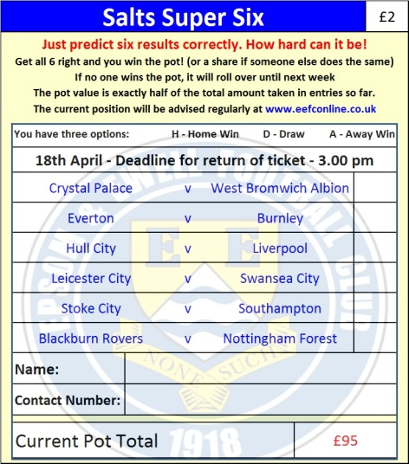
Please note that if there is more than one winner, the prize pot would be shared between the winners. All you need to do now is have a go, as many times as you like!

Good luck!

Combined Counties League - Premier Division
Saturday, 18th April 2015 - Kick-off 3.00 p.m.
Epsom and Ewell  (Royal Blue & White hoops) | V |  | Knaphill  (All Red)
 | NUMBERS
Michael Eacott |  |  | Richard Shelley
James Taylor |  |  | Connor Close
Alex McKay |  |  | Timmy Taylor
George Murphy |  |  | Jamie Doble
Dan Dean |  |  | Matt Morris
Matt Farrell |  |  | Alex Lumley
© Sam Currie |  |  | David Johnston
Daryl Cooper-Smith |  |  | Scott Costello
Kyle Hough |  |  | Josh Watkins
Savva ‘Agi’ Panayiotou |  |  | Arafat Kabuye
Matt Ferdinando |  |  | Jimmy Norman
Anthony Panayi |  |  | Ricky Hogsden
Sam Robinson |  |  | Luca Bertalone
Matt Robinson |  |  | Idris Taiwo
Ben Hayward |  |  | Manni Oloroyde
Alex McGregor |  |  | Mark Nicell
Steve Rowe |  |  | Karl Dallaway
Ali Dewar |  |  | Gurkan Gokmen
Ben Franklin |  |  | Nahum Green
Glyn Mandeville | MANAGER |  | Keith Hills
Matt Smith | ASSISTANT |  | Steve Pearman
Steve Eacott / Alex McKay | COACHES |  | Roland Baker
Ken Jones | PHYSIO |  | Trevor Smith
REFEREE: T.Yesilyurt (Wandsworth)
ASSISTANTS: J.Lidbetter (Surbiton), M.Etheridge (Walton on Thames)
Today’s Match and Match ball are
sponsored by the Eacott Family

THANKS FOR YOUR SUPPORT THIS SEASON

The new season begins on
Saturday 8th August 2015!

